Is monopoly necessarily less efficient then perfect competition?

Ayhan Tunc
500119
Faculty of Law & Social Sciences
Graduate diploma in economics
Economic principles (153400115) Term 1
2010-2011
Word count: 1987

The discussion that will commence henceforth, has been considered extensively by economist and has found it self at the centre of intellectual discourse for a long time. It is the general theory of the ‘firm’ that provides crucial insights in understanding the wider economic system. However, more significantly than this, it facilitates model building for economists to study the wider implications of government policy. Although one might conclude that such models are completely divergent from anything observed in reality nevertheless, this does not diminish its usefulness. A model may yield valid conclusions even though its assumptions are unrealistic. I will provide a very simple synthesis of both models. Henceforth, I will attempt to access whether perfect competition is more efficient compared to monopoly using an empirical study to substantiate or refute this point. I would also like to take this opportunity to state the obvious that all firms within these models are profit maxi-misers.

The perfectly competitive market is distinguished by four main essential characteristics. First, the products of the firm in the industry are identical, so much so that consumers are indifferent to anyone producer, since the products are indistinguishable and therefore homogenous. The second assumption is that there are a large number of producers, and consumers. This particularly means that the individual firms output is relatively small compared to the total output, thus the individual firm is incapable of affecting the price of the product. The third trait of perfect competition is the total freedom of resources. Resources can readily move into the market in response to certain signals, primarily profits new firms can move in and out of the market without hindrance. The fourth and last assumption is the state of perfect knowledge. Consumers, and firm’s posses perfect knowledge; decisions about production and consumption are made under conditions of certainty.

With these assumptions the equilibrium of the firm is usually derived for the short run and the long run. The individual firm is an output adjuster as it is not able to directly control price it can only shift its supply curve to maximise profit. Each firm aims to Π= TR-TC, since TR=P.q ‘simply involves equating price with marginal cost’. The demand curve is a horizontal line for the individual firm and marginal revenue is equal to price. Fig 1,2 is an illustration of both the short and long run equilibrium of industry in perfect competition.

Fig 1: Short run equilibrium for perfect competition.

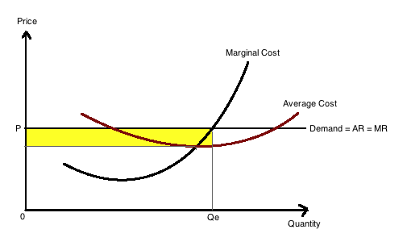

Fig 2: Long run equilibrium for perfect competition.

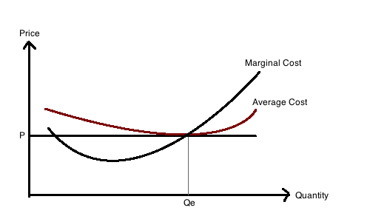

Monopoly like perfect competition is an extreme case, it is held to exist where a firm is the sole supplier of particular good or service in a defined market. The second defining feature is the demand for the product must be reasonably independent of the price of other products. Hence, it has an elastic demand curve it is negatively inclined unlike perfect competition were the demand curve is horizontal and inelastic. Monopoly may arise from a number of sources, exclusive control over important inputs, economies of scale, patents, network economies, government licences or franchises. These assumptions clearly present a barrier to any other firm that may intend to enter the market. Another significant feature of monopoly that differentiates it from perfect competition is the equalisation of marginal revenue and marginal cost as illustrated by fig 3.

Fig 3: Equilibrium for a monopolist.

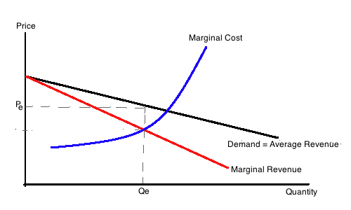

This means that a monopolist can only expand its output by reducing the price, in contrast to the perfect competitor who can expand his sales by as much as it chooses without having to accept a reduced price.

This simple presentation of both models is sufficient for our main discussion of assessing whether monopoly is necessary less efficient than perfect competition. There seems to be a consensus among the economic literature on the apparent benefits of perfect competition in relation to monopoly. Thompson (1977) effectively proposes that the major economic significance of perfect competition is the benefits that it affords consumers and the efficiency, with which it allocates resources. ‘Under condition of long run equilibrium consumers are able to buy the product at the lowest possible price consistent with covering the costs of production’. Since price is barely sufficient to earn a minimal profit, and keep the firm from bankruptcy the net benefits accrue to the consumer in terms of low prices that are just above the production costs as illustrated in fig 2. Hence every firm is believed to produce at their maximum efficient output rate hence, all scale economies are realised. Cohen & Cyert (1975) assert that due to the negative slope of the monopolist supply curve it means that a smaller rate of output is sold than would be the case in perfect condition. ‘Hence under monopoly, consumers pay a higher price for and receive less of the product than they would in perfect competition. This is one of the alleged evils of monopoly’. Frank (2010) also presents a similar explanation, which I will explain with the aid of fig 4.

Fig 4: The welfare loss from a monopolist.

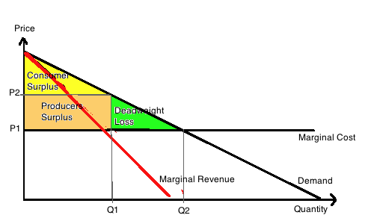

Fig 4 illustrates the profit maximising output for the monopolist is Q1 and the corresponding price is P2. However from the illustration we can note that at Q1 the value of the additional unit of production to consumers is P2, this is greater than the cost of producing it, which is represented by the marginal cost curve. ‘This means that the single price monopolist does not exhaust all possible gains from exchange’. In comparison the perfectly competitive firm will produce at point Q2 at the price determined by P1, which effectively exhausts all possible gains from trade and will lead to a lager consumer surplus including the green shaded triangle, rather than being diminished by monopolist practices such as price discrimination. Price discrimination occurs when the monopolist is able to charge different rates for different social groupings. This process enables the monopolist to access all areas of the economy that may otherwise be illusive due to their high elasticity. In the perfect competitive the green triangle would remain as consumer surplus. The loss of consumer surplus in a monopolist model illustrated by fig 4 is often referred by the texts as the ‘deadweight loss from monopoly’.

The present evaluation has so far been fairly limited in its implication to our overall discussion of monopoly. The academic literature thus far has only scratched the surface of the endemic problem that face monopolist industries. They only seem to focus on ‘allocative efficiency’ to the exclusion of all other types of efficiencies, which are more significant in many instances. This according to Leibenstein (1966) was a conceptual mistake by micro economists. A shift from monopoly to competition has two possible effects, which are identified by Leibenstein and Comanor (1969) the first is elimination of monopoly rents and the second is reduction in unit costs. Although both should be included in assessing the welfare losses however, only the first is examined. Examples of such studies include Harberger (1959) and Schwartzman (1960) who computed only a small benefit of relocating resources between 1 to 6 percent. ‘The empirical evidence, while far from being exhaustive, certainly suggests that the welfare gains that can be achieved by increasing only allocative efficiency are usually exceedingly small’. Leibenstein introduces a new concept into the discussion that explains more profoundly the cost of monopolist firms, ‘X-efficiency’. He reports that when his theory of X-efficiency is employed and adopted significant gains are recorded up to 30% and 25% reduction in costs. He states that X-efficiency exists and improvements in X-efficiency are an important source of increased output. This improvement in X-efficiency is significantly dependant on the nexus of pressures from the external environment on individual decision makers, and this is part of the second element of X-efficiency, Leibestein identifies as ‘external motivational efficiency’. The lower the intensity of pressure upon the firm from external competition the lower will be its output. ‘There is no need for monopolists to minimise costs or transit pressure through the organisation to improve performance since higher costs can be passed on to consumers.’

The empirical work conducted by Thomas G. Weyman-Jones, ‘Productive efficiency in a regulated industry’ (1991) provided a significant attempt to measure the efficiency of UK public utility companies, and the specific impact of the regulatory regime had on their efficiency ratings. He uses the methodology developed by Farrell (1957), which is termed as non-parametric linear programming. It is important to identify that although the study is not focused on the definite terms that we have described monopoly to be, nevertheless they are publicly owned companies and thus sheltered from competition. The twelve electricity boards are not generators of energy but responsible for providing energy to consumers. They are regulated by price capping (RPI-X-Y), incentives. The X variable is provisions to cut costs, and the Y variable is a price competitor element between the companies. Hence, the relative efficiency of the separate supplier will be of great importance to consumers. The model adopted by Weyman-Jones assumes two inputs ‘labour’ and ‘capital’ and three outputs retail sales to ‘domestic’, ‘commercial’, and ‘industrial’ consumers. The results according to the author are striking, and provide important results for the deregulation argument. ‘The boards do differ significantly in efficiency… boards are not efficient across all sectors’. The regulatory regime focuses entirely on the domestic market leaving the commercial and industrial fairly unregulated this inevitably results in low efficiency in these sectors only five companies are identified to be efficient out of the twelve in the study. Out of the five the commercial and industrial consumers all-fair badly compared to domestic consumers. Weyman-Jones conclude that due to the narrow focus of the regulation upon the utility firms they were not able to exhibit efficiency in areas that lack competition or regulation. ‘The regulation of yardstick competition (variable Y) will prove difficult to implement successfully simply because the different boards are not comparable’ (emphasis added). This will invariably mean that any attempts to increase competition, and thus efficiency will inevitably fail due to the lack of close substitutes; as some do not share the same geographical location, history and tradition are also identified as being important issues in creating inefficiency among the firms.

Although the study provides important and substantial evidence for the deregulation of the utility industry, however as Button & Weyman-Jones (1992) point out a failure of experimental design causes many researchers to choose their samples before, without considering whether efficiency measures are being implemented. The article looks at the empirical studies conducted in this field and states that in all instances including the study presented above inefficiency is very sensitive to the researchers assumptions, and also to the employed methodological tools. ‘In many cases the stochastic frontier approach and the non-parametric programming approach not only yield very different estimates of inefficiency for the same sample, but the distribution of inefficiency itself varies according to the measurement method used’. According to Button & Weyman-Jones the efficiency literature contains two themes. On the one hand there is the following of the fundamental work of Farrell a focus on measurement, which a lot of work has been submitted. The other is more of a cause and effect explanatory field developed by Leibenstein. ‘What is missing at present, is a serious effort by investigators of efficiency measurement to relate their choice of sample or experimental design to tackling issues raised by Leibenstein and other’.

Conclusion: It is clear from the discussion above that perfect competition is increasingly more efficient than monopoly. I have presented theoretical analyses and also supplemented this further with empirical analyses. What is clear is that ‘efficiency’ as a definition is inadequate for in-depth analyses and one would have to adopt the term developed by Leibenstein of X-efficiency. However, as academics have acknowledged there is a weakness in the methodological approaches, which have a detrimental effect on studies of efficiency. Although there may be empirical faults or conceptual problems the economic literature is unanimous in there critical analyses of monopolist enterprises compared to perfect competition, and one can clearly see the effects that competition or strict regulation has on firms who were once protected as public companies as illustrated by Weyman-Jones. The commercial and industrial sector were clearly lacking efficiency due to less stringent application of regulations compared to domestic consumers, who had benefited from increased efficient supplier. We can apply the findings of this paper although based on simplistic models to real economic markets dominated by firms, some of which are monopolists and others abide by competition.

Bibliography:

- Arthur A. Thompson Jr. (1977)
Economics of the firm: theory and practice. (2nd edition)
Prentice hall International publications

- K J. Button & T G. Weyman-Jones. (1994)
X-effeciency and technical efficiency.
Public choice, Vol. 80 No 1-2 pp 83-104.
Published by: Springer.

- W S. Comanor & H. Leibenstein (1969)
Allocative efficiency, X-efficiency and the measurement of welfare losses.
Economica, new series Vol. 36 No. 143 pp. 304-309
Published by: Blackwell publishing.

- K J. Cohen & R M. Cyert (1975)
Theory of the firm: resource allocation in a market economy (2nd edition)
Prentice hall international publications

- R H. Frank (2010)
Microeconomics and behaviour. (8th edition)
McGraw hill publishers.

- H. Leibenstein. (1966)
Allocative efficiency vs. “X-Efficiency”.
The American economic review, Vol. 56 No. 3 pp 392-415.
Published by: American economic association.

- M A. Crew. (1975)
Theory of the firm.
Longman press.

- Thomas G. Weyman-Jones. (1991)
Productive efficiency in a regulated industry. The area electricity boards of England and Wales.
Energy economics. Vol. 13 No. 2 pp 116-122

M. Crew (1975:63)
R. Frank (2010: 374,375)
AA. Thompson Jr. (1977:366)
K J. Cohen & R M. Cyert (1975:202)
R. Frank (2010:397)
W S. Comanor & H. Leibenstein (1969)
H. Leibenstein (1966: 395)
H. Leibenstein (1966:407)
H. Leibenstein (1975:604)
T.G. Weyman-Jones (1991:120)
T.G. Weyman-Jones (1991:122)
K.J Button & T.G. Weyman-Jones (1994:98)
K J. Button & T G. Weyman-Jones (1994:100)

