Date
11
08
Fall
Marcelo Bayas
Student Number: 1174841/6

Module Code: 4ECQ552
Marker: Karen Kufu
Course: International Business & Languages
Analysing the Southeast Asia financial crisis

Table of Contents
1.0 Southeast Asian Crisis: A Global Economic Issue 2
2.0 Causes of the East Asia Financial Crisis 3
2.1 How Was The Crisis Handled 4
4.0 Effect on the Global Economy 8
5.0 Why Emerging Economies Need Capital Flows 10
6.0 Lessons and Recommendations of Future Policy 14
References 15

1.0 Southeast Asian Crisis: A Global Economic Issue
We have been moving away from a world in which nations, organisations and trade is separated (or limited) by geographic locations, time zones, currencies, culture, language, government regulations and policies, and financial systems. National economies are now highly integrated and interdependent, this process is usually referred to as globalisation.
The lack of transparency of financial and corporate affairs made the Southeast Asia Financial crisis a global economic issue. The Global financial system is heavily dependent on financial and corporate data transparency. The lack of transparency in Southeast Asia (and other parts of the world) is mainly in regards to financial markets, the major players, their decisions and how money is moved across national borders. Future financial crises cannot be avoided this issue of transparency is not addressed (Khor, n.d.).
“Every year developing countries lose approximately $1 trillion in illicit financial flows, the proceeds of crime, corruption, and tax evasion.”
(HRW, 2008)
Furthermore, financial markets are interlinked, so the activity if Asian financial markets affects other financial markets, such as the US, Europe and Japan (Nanto, 1998).
During the 1980s and 1990s, Asian economies accounted for 30% of world output, 50% of world growth and two-thirds of capital spending (McCall, 1998). Thus, a financial crisis in this region will undoubtedly spread to other parts in the globe, making it a global economic issue.

2.0 Causes of the East Asia Financial Crisis
The 1997 Southeast Asian (SeA) financial crisis was the second biggest financial crisis of the 20th century, second only to the 1929 great depression, and deeply affected those countries that took the full impact. In 1998 it quickly spread to north Asia, Russia, Europe and North and South America, and caused approximately one third of the world to go into recession.
"The loss of global financial wealth in the three months following peak in July
[1997] was 2.3 trillion dollars”
(Karunatilleka, 1999)
Krongkaew (1999) points to six major factors that attributed to the crisis. However, the focus of this report is on four of these: excessive current account deficit, financial mismanagement, uncontrollable capital flow, and a rigid exchange rate.
The G7 blamed the crisis on the misjudgement of Southeast Asian banks and financial firms about the real state sector, stock markets (Khor, n.d.), as well as bad decision-making, such as unsustainable economic policies adopted by SeA countries, in particular the one that unofficially pegged their currencies to the dollar without hedging against exchange rate risks (Karunatilleka, 1999).
Other viewpoints blame the crisis on the rapid development of the global financial system. Since the late 1980’s, there has been an increase in the financial liberalization and deregulation of international capital markets. This, combined with the speed of communication and transactions through ICT and the global role of large financial firms has led to a rapid movement of large amounts of short-term capital across international borders (Khor, n.d.). The daily movement of capital in the world is estimated at around $2trillion (Beeson and Rosser. 1998)
Thailand and neighbouring nations shared factors such as “high foreign borrowing and current-account deficits; a worrying proportion of bank lending going to finance a property glut; dollar-linked exchange rates, and slowing export growth” (economist, 1997), so the crisis spread throughout the region over night.

2.1 How Was The Crisis Handled
Regional leaders and international bodies took number of steps to contain the crisis. In 1997, the IMF organised a rescue package of over $117.7bn for Thailand, Indonesia and Korea. The rescue package for Indonesia had to be negotiated three times because the Indonesian Government refused to accept the conditions imposed by the IMF (Karunatilleka, 1999).
In February 1997, Thailand’s investors and companies decided to convert the baht into dollars to protect against possible currency devaluation. The Thai Central Bank decided use its dollar reserves (nearly $20bn) to buy baht so as to keep the Thai baht value fixed to the dollar. In July 2 1997 Thailand run out of dollars and the baht falls more than 15% (Suk H, Mahfuzul. 2002). The devaluation of the Thai currency rapidly increased inflation, so the Thai Central bank increased interest rates to contain inflation (Beeson and Rosser. 1998)
In December 1997, Thailand’s interest rates peaked 26% and during the year the stock market fell 55.2%. In the same year, the Philippines stock markets fall 40% and interest rates peak 85%. In September 1998 Malaysia imposes further capital flow controls and fixes its currency at RM3.30 to the dollar (Karunatilleka, 1999).
At the time, the Japanese economy was experiencing a depreciation of the Yen. The US stepped in, on the basis that if the Japanese economy continued to fall, the SeA crisis will get worst and affect exports to Europe, US and Canada. In June 1998, the US Federal Reserve Board and the Japanese financial authorities arranged a $6bn dollar bailout to stop the Japanese Yen from falling further (McCall, 1998).

3.0 Short-Term Capital Flows and Why it Affected Southeast Asian Economies
Short-term capital flows are private capital investments on equities (e.g. stocks) with maturity of less than a year. These private investors can withdraw their investments almost immediately, so when they perceive that their investment is at risk, they simply withdraw it and invest it in a “safe heaven” e.g. US Government bonds that offer fixed interest rates.
In 1995, the dollar begun to appreciate, and it caused SeA currencies to appreciate too. SeA exports became expensive to non-dollar buyers, and the labour-intensive and export-dependent nations lost competitiveness in exporting markets (Nanto, 1998).
Furthermore, foreign banks financed a significantly proportion of the SeA lending boom, which in turn inflated SeA assets prices to high unrealistic values. The money supply available for SeA nations grew too fast in relation to real economic growth. This was, in fact, another factor that contributed to the crisis. This eventually created and an over-supply of (under-demanded) office buildings, houses and factories. The Thai property market deeply affected the financial market and in Korea, conglomerates would invest in inefficient factories (Karunatilleka, 1999).

“The experience of industrial countries has been that property price bubbles were followed by protracted and substantial declines in prices: average falls of almost 70% in real terms for commercial property and 30% for residential property spread over about five or six years”
(Karunatilleka, 1999)

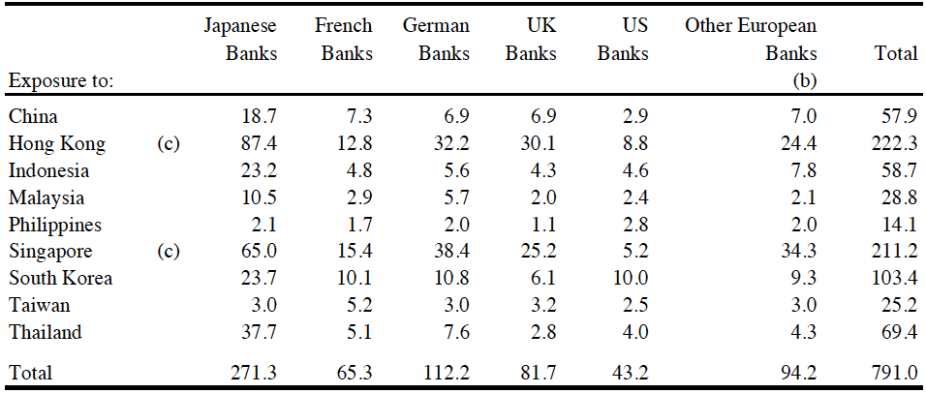
Source: Bank of International Settlement, reproduced in “The Asian Economic, 1999”p15
Table 1 – June 1997: International Banks lending to Asia ($billions)

The SeA crisis had the biggest impact on Thailand, Indonesia, Malaysia and South Korea, but why?
Table 1 shows that foreign banks lent around $260.3bn to Thailand, South Korea, Indonesia, and Malaysia. Of that amount, 64.07% (or $166.8bn) were short-term loans (Karunatilleka, 1999).
A loan repayments crisis eventually unfolded in Thailand, which caused foreign short-term creditors to have fears of loan defaults and so decided to withdraw funds from Thailand’s financial institutions (Krongkaew, 1999)
Shortly after, the Central bank in Thailand reported that 8% of loans made by Thailand’s largest financial firms were non-performing. In Korea it was 6% and in the Philippines it was over 3% (Karunatilleka, 1999). This was a problem for international banks because some of them had to write down claims, particularly against corporate borrowers.

Table 2 shows that, in relation to GDP, short-term capital flows in Thailand were substantial, peaking 12.7% of GDP in 1995. FDI, however, peaked 0.9% of GDP in 1996. Similar activity was seen across the region, but Thailand was the most severe. Short-term capital should have never made up such high proportions of Thailand’s GDP. Foreign Direct Investment (FDI) should have been encouraged instead.
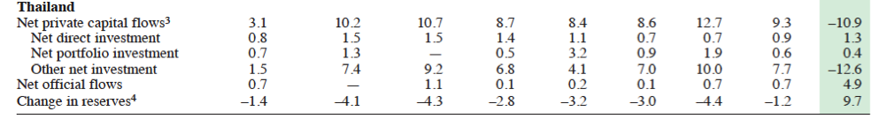
Table 2 – Thailand Capital Flow (in percentage of GDP)

Source: IMF Regional Economic Outlook, 1997.

In 1996, $70bn dollars poured in to Thailand, Indonesia, Malaysia, the Philippines and South Korea. By 1997, nearly $102bn of left those countries (Khor, n.d.). In Thailand, capital outflow was equivalent to -78.33% change in the current account (IMF, 2010). Between 1996 and 1997 the Thai economy alone is estimated to have lost over five trillion baht (Beck, n.d).

4.0 Effect on the Global Economy
In May 1998 over five million jobs were lost in the region because of the crisis. South Korea alone had about 1.2 million job losses caused by the rate of company closures, which ran at 100 per day. In Thailand, 56 of its major finance companies, with assets valued at $20bn, were forced to shut, whilst unemployment was estimated to rise to 5.6% (or 2 million) by the end of 1998 (McCall, 1998).
In early 1998, it would have been possible to buy the entire South Korean financial industry for $4 billion (about the amount Bill Gates makes on a good day for the U.S. stock markets).
(Beck, n.d).
In 1998, the IMF calculated that the SeA crisis would cause global economic growth to contract by 1% by the end of year. From June 1997 to January 1998, worldwide equity losses in Asia amounted to $700bn, of which over $30bn were US investors’ losses. In 1997, European Banks had the most exposure (Table 1) and their losses amounted to over $20bn. European, Japanese and US exposure totalled $260bn, $271.3bn, and $43.2bn respectively in mid-1997 (Table 1).
The SeA crisis caused U.S. corporate profits to fall 1.1% in the fourth quarter in 1997. Greenfield projects and export orders in SeA had to be cancelled, and many US multinational firms experienced losses caused by currency exchange fluctuations (McCall, 1998).
Nearly 30% (Table 3) of all US exports were shipped to Asia in 1996. But the price of these U.S. exports became expensive (to SeA consumers) due to the devaluation of SeA currencies. In light of this, demand for US imports in SeA reduced. The U.S agricultural industry was forced to reduce production, which meant exporters sold less and settled for fewer profits. Others affected includes exporters of industrial machines, semiconductors and aircraft equipment (McCall, 1998).

In the financial sector, Asian stock market chaos causes the Dow Jones to fall 7% (554 point) on 27 October 1997. Followed by a sudden drop in Latin American stock markets and interest rates doubling to 43% overnight in Brazil (Karunatilleka, 1999). A year later, the contagion effect of the SeA crisis is in full swing and in July 20 1998 Russia raises interest rates to over 100% over night.
“Asia-related losses included a $60 million loss on stock derivatives by Salomon Brothers, a $160 million emerging market debt trading loss by Chase Manhattan Bank, and a $250 million currency trading loss by Citicorp.”
(McCall, 1998)
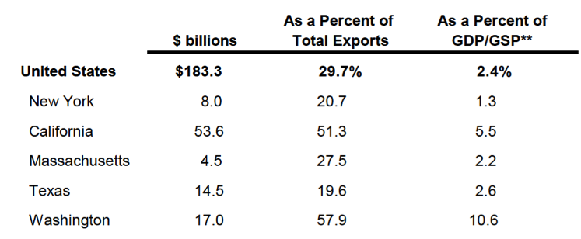
Table 3 – U.S. Exports to South Asia 1996 (Selected States)

Source: “Asia's Financial Crisis Will Alter U.S. Regional Growth Patterns”, reproduced in “The East Asian Economic Crisis: A Background Report on the Implications for New York City”, 1998 p26
Includes: China, Hong Kong, Indonesia, Japan, South Korea, Malaysia, Philippines, Singapore, Taiwan and Thailand

5.0 Why Emerging Economies Need Capital Flows
Since mid-1980s there has been many political reforms as political leaders begun to see that progress is directly affected by a country’s political and economic system (McGraw-Hill, 2010). Empirical evidence suggests that those nations that open their capital markets can benefit from the advantages associated with international capital flows (Economic report of the president, 2004).
But why is the flow of capital beneficial for emerging economies? Well, in a domestic capital market, the number of investors is limited to the size of the population, and similarly, domestic markets have a limited supply of funds available to borrowers. However, the global market is a much larger pool of investors and borrowers, and therefore it is more liquid.
_{Interest rates}
_{Quantity ($)}
DS
GS
D1
D2
D
12%
10%
%
Figure 1

Figure 1 illustrates this point. The vertical axis represents the cost of capital and the horizontal axis represents the amount of capital available (in dollars). DS is and GS are the domestic and global supply curves of funds available, and D1 is the demand curve for funds. Domestic firm can borrow quantity D1 at 12% interest. However, in the global market it can borrow more funds at quantity D2, for a lower cost at 10% interest. Therefore, the global market offers more funds for a cheaper price. Hence, when emerging economies liberalise their capital markets, their domestic firms can enjoy borrowing at low interest rates and fund investment (e.g. in factories, machinery, training, technology). This will in turn increase national output and employment (Economic report of the president, 2004).
Free flow of capital also allows domestic investors to diversify their investments internationally and reduce the risk of investments (McGraw-Hill, 2010).
Generally, emerging markets and developing countries favour FDI over other types of capital flows, such as bank investment and portfolio investment. FDI occurs when a firm (most likely) obtains control of a firm in another country, and usually takes place through the purchase of an enterprise, or shares (at least 10%) in the firm it wishes to control.
FDI is the most favoured form of capital flow because they are long-term investments that take years to withdraw and liquidise, whereas Bank and Portfolio investments are subject to quick reversal of capital flows (Economic report of the president, 2004). One of the main advantages of FDI is that it tends to be resilient during financial crises, as it was during the SeA crisis (Loungani and Razin. N.d.). Table 4 shows different (economic theoretical) effects that emerging markets and economies can benefit from. Table 5 on the other hand shows some of the negative aspects of FDI on the host country.

Table 4 – Positive Effects of FDI in the Host country

Source: Adopted from McGraw-Hill, International Business, 2010

Resource-transfer benefits | Employment effect benefits | Competition and economic growth benefits
Technology is transferred into the host nation through the firm undertaking FDI. Technology “stimulates economic development and industrialization”. (McGraw-Hill, 2010)  FDI can provide much of the technology needed to promote economic development.  A study found that FDI of foreign firms increased labour and productivity of firms in Sweden. | FDI helps create jobs in the host country and reduce unemployment. The MNE would either employ local workers or local suppliers will employ more workers because of the interaction with the MNE.  When Toyota established plants in France it created 2000 jobs, and another 2000 in support industries. | When FDI often takes the form of Greenfield investment (establishing operations in a foreign country), competition in the host country market increases. This increases the competitiveness of host country firms and lead to a reduction in prices, thus increasing the welfare of the citizens of the host country.  In 1996, MNE’s like Walmart and Tesco made Greenfield investments in South Korea. Local chains like E-Mart had to improve their operations efficiency and reduce prices. This was beneficial for S. Koran consumers.

Table 5 – Negative Effects of FDI in the Host country

Source: Adopted from McGraw-Hill, International Business, 2010

Harmful effect on competition | Effects on the BOP
MNE’s that invest in Greenfield projects tend to have more economic power than local competitors. Thus, MNE’s can potentially drive local firms/competitors out of business by offering lower prices. Once these local firms have collapsed, MNE’s can monopolise the market and raise prices, affecting the welfare of the consumer. | Earnings made by the MNE in the host country eventually leave to the parent company (situated abroad) and appear as outflow of capital in the BOP. The problem is when MNE make large earnings; meaning the outflow of capital that appears in the host country’s BOP is large too. Hence, it can distort the real economic standpoint of the host country.

6.0 Lessons and Recommendations of Future Policy
What then, has the world learnt from the SeA crisis, and how can nations prevent further economic crises?
Some economists and politicians emphasise the moral hazard outcomes from the SeA crisis. Their opinion is that if banks and countries make foolish political and economic decisions, and their economic structures fails, they should be allowed to go bankrupt. They argue that they make imprudent economic and political choices because if things go wrong, the IMF can always bail them out (BBC News, 1998). In order to avoid this, emerging economies should not open their capital markets and deregulate their external finances too fast, as have the SeA nations and Argentina. They must establish regulation and policies that protects their economy from international capital flows and prepares them for possible negative consequences (Khor, n.d.).
Policies in regards to the transparency of corporate and financial affairs of all nations must be passed to reduced the likeliness of financial crises. A financial crisis occurring is high when there is poor transparency of financial and corporate affairs (Shehzad and Haan, 2008). Furthermore, the policies of the IMF can often determine the financial fate of many nations. Currently, there is a lack of transparency in regards to how the IMF sets policies. Thus, the IMF should be subject to investigation (Khor, n.d.).
Policies to monitor international capital flows should be established, with particular focus on short-term capital flows. Significant amounts of short-term capital flows in a country may eventually lead to a financial crisis. Furthermore, emerging economies that want to open their capital markets further should adapt exchange rate policies that best suits their economy. Pegged and thus inflexible exchange rate policies are vulnerable to international speculation, which in turn affects the economic standpoint of a country (Xiaoling, 2007).
Word count: 2448 (excluding references and tables)

References
Khor, M.,(N.d.) the economies crisis in Asia:Causes, effects and lessons. [online] Available from: http://siteresources.worldbank.org/INTPOVERTY/Resources/WDR/malaysia/khor.pdf [accessed 3 March 2011]
McCall, C., (1998). The East Asian Economic Crisis: A Background Report on the Implications for New York City. [online] Available from: http://www.osc.state.ny.us/reports/nyc/economic/tm199/tm199ad.pdf [accessed 2 March 2011]
HRW., 2010. US: Promote Global Financial Transparency at G20 Summit. [online] available from: http://www.hrw.org/en/news/2010/11/08/us-promote-global-financial-transparency-g20-summit [Accessed 5 March 2011]
Nanto, Dick., (1998). THE 1997-98 ASIAN FINANCIAL CRISIS. [online] Available from: http://www.fas.org/man/crs/crs-asia2.htm [accessed 12 March 2011]
Karunatilleka, Eshan., (1999). The Asian Economic Crisis. [online] available from: http://www.parliament.uk/documents/commons/lib/research/rp99/rp99-014.pdf [accessed 10 February 2011]
Koringkaew, M., (1999). Capital flows and Economic Crisis in Thailand. [online] Available from: http://www.ide.go.jp/English/Publish/Periodicals/De/pdf/99_04_02.pdf [accessed 9 February 2011]
The economist (1997). Unpegged. [online] Available from: http://www.economist.com/node/151587 [accessed 12 March 2011]
Suk, H. et al., (2002). The Asian financial crisis: causes and policy responses. [online] Available from: http://findarticles.com/p/articles/mi_qa3674/is_200204/ai_n9026596/ [accessed 10 March 2011]
Beck, J., (n.d.). Responding to Global Crises Using the Change Cycle. [online] Available from: http://www.livrariacultura.com.br/imagem/capitulo/322390.pdf [accessed 12 March 2011]
Economic Report of the President., (2004). The annual report of the council of economic advisers. [online] Available from: http://www.gpoaccess.gov/usbudget/fy05/pdf/2004_erp.pdf [accessed 12 march 2011]
Razin, A. et al., (n.d.). how beneficial is foreign direct investment for developing countries?[online] Available from: http://www.tau.ac.il/~razin/LounganiRazinrevisedFD1.doc [accessed 11 March 2011]
De Hann, J., (2008). Financial Liberalization and Banking Crises. [online] available from: http://www.finance-innovation.org/risk09/work/6450490.pdf [accessed 10 March 2011]
Hill, C., (2010). International business: competing in the global marketplace. Eight edition. Europe: McGraw-hill Education.

