The competitive environment
Firms must keep abreast of what the competition is doing, so they can develop new product features, new pricing schedules, or new advertising to maintain or gain market share.

Analysis of the market and the competition
Marketing manager size up competitors according to their strengths and weaknesses, monitor their market strategy and try to predict their moves.

Many firms around the globe now make use of Competitive Intelligence (CI). This is the process of gatharing and analysing publicly available information about competitors. Most of the information that companies use comes from mundane sources, such as the news media, the Internet, and publicly available governmental documents. Successful CI implies that firm learns about competitor’s new products and, its manufacturing, and management strategies. Then the firm uses this to develop superior marketing strategies.

Competition in the Micro-environment
Competition in the micro-environment means that product alternatives from which members of the target market may choose.
There are three levels of these choices.

Disposable income – the amount of money people have left after paying for their necessities such as housing, food, clothes, transport, and utilities. Few people are wealthy enough to own anything and everything. Thus, most of the population has a limited disposable income and so are faced with opportunity costs. Do customers keep their money in their back account and let it earn interest, or buy that new iPod? Should I get takeaway, or buy groceries to cook my own food? Should I buy a bicycle to work/university or just take the bus?
Thus, the first part of understanding whom the competition is means understanding all the alternatives that customers consider.
Product competition – this is when competitor’s offerings attempt to satisfy the same customers’ needs and wants. For example, a customer can decide to either go to the gym or buy the equipment to exercise at home.
Brand competition – this is when competitors offer similar goods and services, all seeking to increase their share of the market. For example, a person seeking to get fit, may can choose from LA Fitness, Aquaterra, Virgin Active etc.

Competition in the macro-environment
When talking about examining the competition in the maco-enviromnment, we mean that marketers need to understand the big picture, that is, the overall structure of the industry. Four structures describe different amounts of competition.

Monopoly – when a seller controls the market. Because it the only player, it feels little pressure stop keep the prices low and produce quality goods and services.

Oligopoly – refers to a market with a relatively small of sellers, each holding a substantial amount of market share in a market that has many buyers.

Monopolistic competition – there are many sellers who compete for buyers in the market. Each for however, offers a slightly different product, and each has a small share of the market. For example, shoe manufacturers vigorously compete with one another to offer consumers unique benefits.

Perfect competition – when there are many small sellers, each selling basically the same product or service. In such industries, no single firm has a significant impact on quality, price, or supply.

Technological environment
Technology is an investment that firms can’t afford not to make, as it provides firms with important competitive advantage. Many technological developments affect profoundly the marketing activities. Free phone numbers, and the Internet made it possible for consumers to buy almost anything without them leaving their homes. Furthermore, production processes have also improved and evolved due to technology developments, such as automated orders and stock control.

Political and legal environments
The political and legal environment refers to the local, national and global laws and regulations that affect businesses. Firms that choose to stay within their national borders only have to worry about national laws and regulations. Firms that operate globally must understand complex political issues that affect how they do business and their potential for success.

Political constraints on trade
Global firms know that political actions taken by the host government can drastically affect a business’s operations. An example of how this has occurred in the past is nationalization. This is when the government reimburses a foreign company for its assets after taking it over. The Chavez government in Venezuela nationalized American companies, but did not give any reimbursements.

Regulatory constraints on trade
Governments and economic communities impose numerous regulations about what products should be made of, how they should be made, and what can be said about them. Firms usually have to change their production processes to comply with local laws and regulations.

Local content rules stipulate that a certain proportion of the product must consist of components supplied by industries in the host country or economic community.

Demographics
The first step of understanding the characteristics of society is to look at the demographics. These are the characteristics that measure observable aspects of a population such as size, age, gender, religion, income, social class, family structure, and education. Demographic studies can be of great value to markets in helping to predict the size of the markets for many products.

Values
Different countries have cultural values or deeply held believes as to the right and wrong ways to live. Such believes affect every aspect of our lives, and affects marketing strategy and approach to the consumer.
For example, more than 8.2 million women in more than 50 countries read different versions of the cosmopolitan in more than 8 different languages. However, because of local norms about modesty, some women hide the magazines from their husbands. For example, the cosmopolitan in Sweden does not include many topics on sex, simply because the culture is so open about the topic that it doesn’t grab the readers attention.
Furthermore, in Hong Kong, time is a core value, and thus, business meetings tend to be precise and start promptly. However, in other countries such as some in Latin America, if a meeting starts at 10am people won’t start arriving until 10:30am.
Norms and customs
Values are general ideas about good and bad behaviours. From these values flow norms, or specific rules dictating what is right or wrong, acceptable and unacceptable. Some specific norms include:

Customs – is a norm handed down from the past that controls basic behaviours, such as division of labour in a household.
Mores – customers with strong moral overtone. Such as forbidden behaviours, such as incest or cannibalism.
Conventions – are norms regarding the conduct of everyday life. These rules deal with the subtleties of consumer behaviour, such as the “correct way” to way to furnish a home, dress and host dinner parties.

All three types of norms may determine what behaviours are appropriate in different countries. For example, in some European countries and the Middle East, dinner is not eaten until around 9pm. People on these countries are amused by British visitors whose stomachs rumbling at 7pm.
Language
The language barriers is one obvious problem confronting marketers who wish to break into foreign markets. These signs are not just potentially embarrassing, but they can also affect labelling and usage instructions, advertising and personal selling. It is important for marketers to work with local people who understand the language so as to avoid futures that may result.
The brand name of a product, one of the most important signals marketers can send about the quality and character of the product, can have different meanings in other languages and get mangled in international markets. For example, Spanish bread called “Bimbo”, and a Scandinavian car warmer called “Super Pis”.

Organisational or SBU objectives
After constructing a mission statement, top management translates that mission statement into organisational or SBU. The goals are identified and from the mission statement and identify what the firms wants to accomplish in the long term and the long term. If the firm is big enough to have multiple SBU’s, each SBU will have its own objectives relevant to its operations.
The effective objective needs to be SMART. An acronym for Specific, Measurable, Achievable, Relevant and Time Related.

Establish a business portfolio
For companies with many SBU’s, strategic planning included making decisions about how best to allocate resources across these businesses to ensure growth for the whole organisation.
Just like an independent business, each SBU is a separate profit centre within the larger corporations – that is, each USB within a firm is responsible for its own costs, revenues and profits.
The range of different businesses that a firm operates its called a business portfolio.
Portfolio analysis is a tool that management uses to assess which products/businesses in the portfolio needs greater allocation of resources, which products are reaching the end of the PLC and must be either sold or dropped, and decide which are most consistent with the firm’s mission.
The Boston Consulting Group (BCG) matrix is one of many models used by management to assist with portfolio analysis.
Also known as the Boston matrix, it focuses on determining the potential of a firm’s existing potential SBUs to generate cash that the firm can use to invest in other businesses.
The vertical axis represents the market growth rate and the horizontal axis represents its relative market share.
Combining the two axis creates four quadrants representing four different types of SBUs. Each has a symbol used to designate business units that fall within a certain range of market growth rate and market share.

Stars
These are products or SBUs that have large market share ion a fast growing market. It can be said that these goods are in the early stages of the product life cycle. Starts generate high amounts of revenue, but also require heavy funding to keep up with production and promotion demands. The firm aims at getting the largest share of loyal customers so that stars can generate profits that can be invested in other SBUs or elsewhere in the company.
The strategic action should be to turn Starts into cash cows, and keep competition at bay by remaining competitive and innovative.

Cash Cows
These have a large market share in a slow growing market. In such markets, there tends to be very few competitors, and competitors often don’t enter the market because of the entry barriers imposed by those few dominant firms.
Firms “milk” cash cows for their profit to fund the growth of other SBUs. Because the market is (at most) growing very slowly, sales start to level out over time. Therefore, the strategy here is for the firm to become more efficient in production processes so as to reduce costs. Such innovation in efficiency could come from “experience effects”.
Furthermore, heavy promotional activities are no longer required because the reputation of the SBU has already been established in the market. Thus, further reducing the costs associated with the SBU.
Nonetheless, too many cash cows with little or no potential growth can become a liability.

Question marks
Also known as a “problem child”. These are SBUs with low market share in fast growing markets. When a product is a Question Mark, it is assumed that the firm has failed to make the product successful or it entered the market too late. Maybe, the product offers (or it is perceived to offer) fewer benefits than those offered by competitors.
Questions Marks are to be analysed with care, because they can become either “Stars” or “Dogs”. After careful analysis of the Question mark products has been carried out, management should decide whether to use capital generated by Stars and Cash Cows to turn Question Marks into Stars. However, if management is not confident with future prospects of the Question Mark, they can decide not to invest any more than they already are, otherwise, the firm runs the risk of investing resources into a product that might eventually fail, thus creating negative cash flow and disappointment.

Dogs
Dogs are SBUs that have low market share in a slow growing market. Typically, these are products that find themselves at the end of the PLC, and might have been Stars and Cash Cows at their prime, but now they face decline. A strategic action for these goods might be to invest to satisfy a niche market, or sell to other firms interested in the product that might be able to re-launch the good.
However, dogs can also be products that failed and offer no prospects for future profitability. Sometimes, the Return on Capital Invested on a “Dog” product is so low that the firm starts making a loss just by having the product in the market.

Develop Growth Strategies (Ansoff Matrix)
Another matrix commonly used by marketers is the Ansoff Matrix. Similar to the Boston matrix, the Ansoff matrix has four quadrants, each providing a fundamental marketing strategy. The vertical axis represents opportunities for growth, either in existing markets or in new markets. The horizontal axis considers whether the firm would be better off putting its resources into existing products or if it should acquire new products.
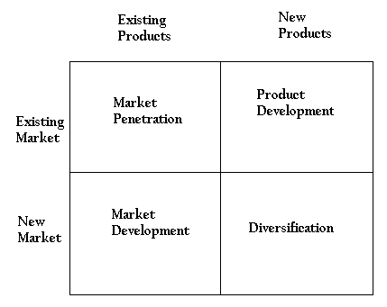

Market penetration – seek to incrtease sakes if existingf products to existing markets such as current users, non-users and users of competing brands within a market. The firm might try to increase sales by cutting prices, improving distribution and conducting promotion aimed at attracting users of competing brands.

Market development – introduce existing products to new markets. The strategy can mean expanding into new geographic areas, or reaching new customer segments within an existing geographic market. Red Bull from Austria to rest of Europe and from shops to clubs and bars.

Product development strategies – create growth by selling new products in existing markets. Product development can be through extending the variation of a product line, or altering and improving the product to provide enhanced performance.

Diversification strategies – introducing new products in new markets to achieve growth.
Consumer behaviour

“The study of the processes involved when individuals or groups select, purchase, use or dispose of products, services, ideas or experiences to satisfy needs and desires.” Solomon

Personal Consumer = individual who buys goods and services for his or her own use, for household use, for the use of a family member, or for a friend.
Organisational Consumer = A business, government agency, or other institution that buys the goods, services, and/or equipment necessary for the organisation to function.

Buyer decision-making process

- Recognition
- Information search
- Evaluation
- Purchase decision
- Post-purchase behaviour

1 – (Recognition of problem) Difference between actual state and desired state
Problem recognition occurs when a customer sees a significant difference between its current state of affairs and some desired state, and may take place over a period of time. For example, a person is fed-up with the rate of petrol consumption of its car (current state) and realises that a different car would consume less and therefore allow him to save some money (desired state).

In other situations consumers purchasing may be initiated by more emotional or psychological needs. The purchase of a Chanel perfume is likely to be motivated by status rather than any marginal functional superiority over other perfumes.
The advertisement of Kellog’s special K promotes its capability to meet the need for a tasty, low-fat cereal.

Marketers then develop creative advertising to encourage consumers to “recognise” that their “current state” does not equal their “desired state” (this is the marketing strategy). An example of how it is done is through TV advertising showing the variety of positive and exciting outcomes of owning the new product e.g. iPad.

Stage in the DMP | Marketing Strategy | Example
Problem recognition | Encourage customers to see that existing stage does not equal desired state | Develop a TV commercial showing the excitement of owning a new sports car

Influences on customer decisions
Apart from understanding the mechanics of the customer decision-making process, marketers also have to ascertain what influences in consumers’ lives affects this process.
Although the problem is identified, if the difference between the desired state and the current state is small, then the consumer may not take the next step in the CDMP.
The degree to which a consumer intends to resolve the problem depends on two issues: the magnitude of the discrepancy between the current state and the desired state AND the relative importance of the problem.
Internal stimuli
Internal stimuli refer to those factors that source from a customer’s current needs. Internal stimuli will often encourage a consumer to purchase something that he or she needs as opposed to something that is wanted and desired. i.e. I need an oyster card, or a travelling ticket to get to university. I don’t want to buy it, but I must. Compare that to, my friend has a playstation and the guy at game says I can get a discount (external stimuli), thus I buy one. I don’t need a PS, but I buy one because I have been influenced by external stimuli, and thus I want one to “fit” in.
Businesses know that, for example, the one customer’s ideal car may be quite different from that of another customer. You may like sporty cars, your friend BMW, and your father may prefer a Mercedes.
Some of these differences are due to the way in which customers internalise information about the outside world, such as perception, exposure, attention and interpretation.

Perception
Perception is the process by which people select, organise and interpret information from the outside world. We receive information in the form of sensations, the immediate response of our sensory receptors (eyes, ear, nose, mouth and fingers).
Our impressions about products are often based on their physical qualities. The perception process has implications for marketers because, as consumers absorb and make sense of the vast quantities of information competing for their attention, the odds are that any singe message will get lost in the clutter. And if they do notice it, there is no guarantee that the meaning they give it will be the same one the marketer intended.
The issues that marketers need to understand during this process include exposure, attention, and interpretation.

Exposure is the extent to which stimulus is capable of being registered by a persons sensory receptors.
Attention is the extent to which mental processing activity is devoted to a particular stimulus. Consumers are more likely to pay attention to messages that speak to their current needs.
Interpretation is the process of assigning meaning to stimulus based on prior associations a person has with it and assumptions he or she makes about it.

External stimuli

External stimuli factors are those that encourage the consumer to feel the need or desire to own a product or receive a service. These external factors are everywhere and their sole aim is to show customers that certain products or services will improve certain aspects of their life, whether at home, work or anywhere else. It’s not always about the product, or service itself, but also about the values that allow for i.e. self-actualisation.

2 – Information search
If problem recognition is sufficiently strong, the next step in the CDMP will begin.
Information search is the step in the decision making process in which the consumer check his memory and surveys the environment to identify what options are out there that might solve the problem.
The objective in information search is to provide information when and where consumers are likely to search or be exposed to the information. For example, TV, salesmen, showrooms, and websites.

The search may be internal or external. Internal search involves making a review of relevant information from memory. This review would include potential solutions, methods of comparing solutions, and reference to personal experience. If a satisfactory solution is not found then an external search begins.
External search involves personal sources such as friends, family, work colleague and neighbours. External search also involves commercial sources such as advertising and sales people.
Need Recognition
Difference between an actual state and a desired state

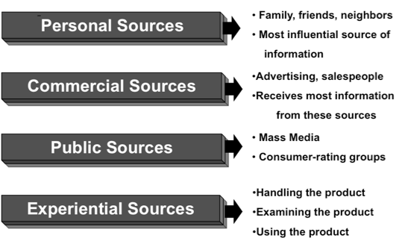

3 – evaluating alternatives
Having gathered sufficient information, the consumer will decide on a small number of products that solve the problem best (products he is most interested in).
The consumer then narrows the choices by deciding which of all the options are feasible, and by comparing their pros and cons or each remaining option.
For example, if a customer looking for a better sports car decides that he wants a Ferrari, but realistically might not be able to afford one right now. So the consumer might go on to narrow down his options by considering the criteria of affordability.
However, as the consumer is left with only a few options, the consumer may look at each option and identify important characteristics, or evaluative criteria. For example, once the consumer has found three alternatives for a good sports car, evaluative criteria may involve pace, power, seats, insurance, colour, comfort and safety.
Marketers, however, will normally play a role in educating customers about which product characteristic they should use as evaluative criteria – usually they will emphasise the dimensions on which their product excels.
Understanding what criteria consumers use and which is more or less important helps sales and advertising professionals to point out brand’s superiority on the most important criteria.

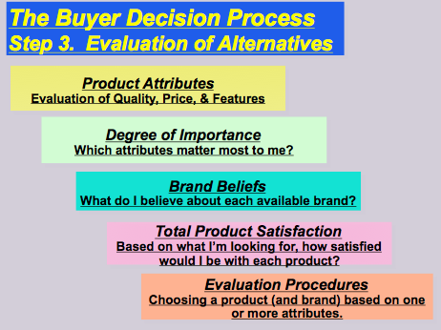

Types of buying: decision behaviour

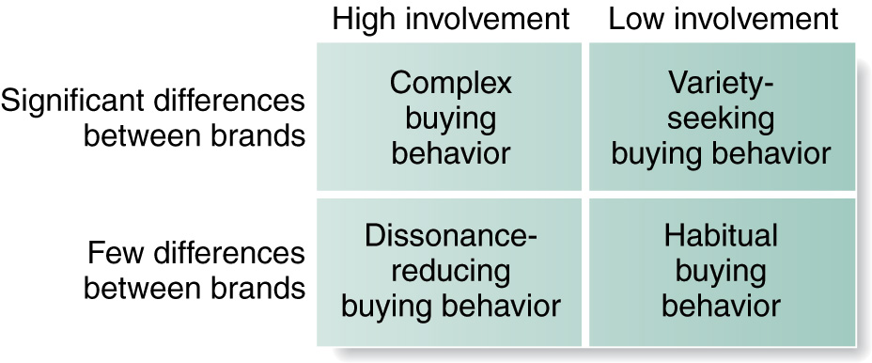

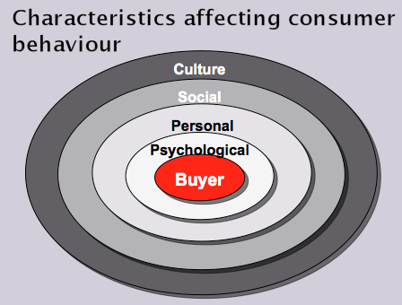

Psychological: There are four important psychological factors affecting the consumer buying behavior. These are: perception, motivation, learning, beliefs and attitudes.
Motivation
The level of motivation also affects the buying behavior of customers. Every person has different needs such as physiological needs, biological needs, social needs (MASLOW)etc. The nature of the needs is that, some of them are most pressing while others are least pressing. Therefore a need becomes a motive when it is more pressing to direct the person to seek satisfaction.
Perception
Selecting, organizing and interpreting information in a way to produce a meaningful experience of the world is called perception. There are three different perceptual processes, which are selective attention, selective distortion and selective retention. In case of selective attention, marketers try to attract the customer attention.
Whereas, in case of selective distortion, customers try to interpret the information in a way that will support what the customers already believe.
Similarly, in case of selective retention, marketers try to retain information that supports their beliefs.

Beliefs and Attitudes
Customer possesses specific belief and attitude towards various products. Since such beliefs and attitudes make up brand image and affect consumer-buying behavior, marketers are interested in them. Marketers can change the beliefs and attitudes of customers by launching special campaigns in this regard.

Personal: Personal factors can also affect the consumer behavior. Some of the important personal factors that influence the buying behavior are: lifestyle, economic situation, occupation, age, personality and self concept.
Age
Age and life-cycle have potential impact on the consumer buying behavior. It is obvious that the consumers change the purchase of goods and services with the passage of time. Family life-cycle consists of different stages such young singles, married couples, unmarried couples etc which help marketers to develop appropriate products for each stage.
Occupation
The occupation of a person has significant impact on his buying behavior. For example a marketing manager of an organization will try to purchase business suits, whereas a low level worker in the same organization will purchase rugged work clothes.
Economic Situation
Consumer economic situation has great influence on his buying behavior. If the income and savings of a customer is high then he will purchase more expensive products. On the other hand, a person with low income and savings will purchase inexpensive products.

Lifestyle
Lifestyle of customers is another import factor affecting the consumer buying behavior. Lifestyle refers to the way a person lives in a society and is expressed by the things in his/her surroundings. It is determined by customer interests, opinions, activities etc and shapes his whole pattern of acting and interacting in the world.
Personality
Personality changes from person to person, time to time and place to place. Therefore it can greatly influence the buying behavior of customers. Actually, Personality is not what one wears; rather it is the totality of behavior of a man in different circumstances. It has different characteristics such as: dominance, aggressiveness, self-confidence etc, which can be useful to determine the consumer behavior for particular product or service.

You are also unlikely to use a brand associated with a group, which you don’t wish to belong to.
Escalas and Bettman (2005) argued that consumers can use brands for the creation and representation of their self image.

Social: Social factors also impact the buying behavior of consumers. The important social factors are: reference groups, family, role and status.
Reference Groups
Reference groups have potential in forming a person attitude or behavior. The impact of reference groups varies across products and brands. For example if the product is visible such as dress, shoes, car etc then the influence of reference groups will be high. Reference groups also include opinion leader (a person who influences other because of his special skill, knowledge or other characteristics).
Family
Buyer behavior is strongly influenced by the member of a family. Therefore marketers are trying to find the roles and influence of the husband, wife and children. If the buying decision of a particular product is influenced by wife then the marketers will try to target the women in their advertisement. Here we should note that buying roles change with change in consumer lifestyles.
Roles and Status
Each person possesses different roles and status in the society depending upon the groups, clubs, family, organization etc. to which he belongs. For example a woman is working in an organization as finance manager. Now she is playing two roles, one of finance manager and other of mother. Therefore her buying decisions will be influenced by her role and status.

Culture: Consumer behavior is deeply influenced by cultural factors such as: buyer culture, subculture, and social class.
Culture:

Culture is the part of every society and is the important cause of person wants and behavior. The influence of culture on buying behavior varies from country to country therefore marketers have to be very careful in analyzing the culture of different groups, regions or even countries.

Subculture:
Each culture contains different subcultures such as religions, nationalities, geographic regions, racial groups etc. Marketers can use these groups by segmenting the market into various small portions. For example marketers can design products according to the needs of a particular geographic group.

Social class:
Every society possesses some form of social class which is important to the marketers because the buying behavior of people in a given social class is similar. In this way marketing activities could be tailored according to different social classes. Here we should note that social class is not only determined by income but there are various other factors as well such as: wealth, education, occupation etc.

4 – Purchase decision
Deciding on one product and acting on this choice is the next step in the decision making process.
Heuristics, or rules, help simplify the decision making process. One such heuristic is “price=quality”. So many people willingly buy the more expensive brand because they assume that if it costs more, it must be better.
Perhaps the most common heuristic is brand loyalty, where people buy from the same company over and over again because they believe that their products are superior. Consumers who have strong brand loyalty feel that it is not worth considering other options.
Creating this allegiance is a prized goal for competitors, because once consumers develop brand loyalty for a company, they may never change their minds over the course of a life time, making it really difficult for rivals to change their minds.

5 – post- purchase behaviour
In the last step in the decision-making process, the consumer valuates just how good a choice it was. The evaluation of a product results in the level of customer satisfaction/dissatisfaction, which is determined by the overall feelings, or attitude, a person has a bout a product after purchasing it and using it.

How do consumers decide if they are satisfied with their purchases?
When we buy a product, we have some expectations of product performance created by a mixture of information from marketing communications, informal information sources such as family and friends, and their own experience on the product category.

Consumers then judge the product performance against these expectations. That is why it is important that marketers create accurate expectations of their product in advertising and other communications.
When a customer experiences regret after making a purchase is regarded to as cognitive dissonance. Reducing dissonance is in both the consumer and marketer’s interest. If the consumer is not happy with the product or service, he/she is not likely to return to the company, and might engage in negative word of mouth. THIS highlights the importance of post-evaluation stage.

Marketers need to get as much information about how consumers feel after they had made their purchase and try to reinforce his feelings of having made the right decision.

Risks associated with CDMP

time

financial

social

paychological/self actualising

Physical/health

Extended problem solving Vs habitual decision-making

Product

Level of involvement

Perceived risk

Information processing

Learning model

Needed marketing
Market research

Definition: Systematic design, collection, interpretation & reporting of information to solve or assist marketing decisions.
Furthermore, marketing research considers the more immediate situation. It is primarily concerned with the provision of information about markets, and the reaction of these to various product, price, distribution and promotional decisions.
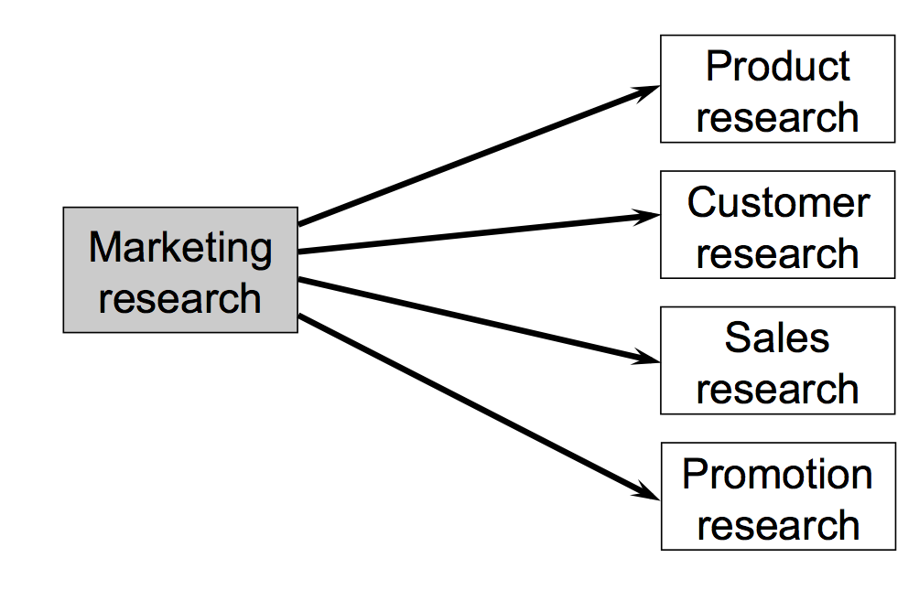
Main division of market research
Product research - Research that gathers and analyses information about the moving of good or services from producer to consumer. It involves the following:

Concept testing
Concept testing is the attempt to predict the success of a new product idea before putting it out on the market. It usually involves getting people’s reactions to a statement describing the basic idea of the product. As such, it is usually pass/fail, go/no go.

A much more fruitful approach is Concept development: the gradual refinement of new ideas into a form that is most likely to be accepted in the marketplace. It not only gives promising ideas a fighting chance, it provides guidance for the communication of benefits, uses, packaging, advertising, sales approaches, product information, distribution, and pricing.

This is a risky undertaking for several reasons:

People cannot know how they will behave in the future, especially in hypothetical situations where the product isn’t even developed.

People are often skeptical of new ideas, and occasionally hostile to them. Radically new products shake up people’s established way of doing things, requiring them to learn new skills. This can make them feel uncertain, incompetent and harried, as they have to relearn what used to be familiar. So, new ideas are unsettling at best and a threat at worst.
People often do not have the imagination to see how the new product would benefit them.
In this overloaded world, people are too busy to take the time to relearn for what they see as small improvements.
These people are not likely to receive a new product with open arms. For these reasons, even “obviously” good ideas which were ultimate successes, like automated teller machines, extended battery life pacemakers, VCR’s, and many once a day medications had major problems when they were first described to people in the concept testing stage of development.

Commercialisation
An effective commercialisation strategy relies upon marketing management making clear choices regarding the target market and the development of a market strategy that provides a differential advantage.

New Product Development
A marketing procedure in which new ideas are developed into viable new products or extension to existing products or product ranges. There are eight different stages, and these are:

New product strategy
Providing clear guidelines about which product/market the business is interested in serving, senior management staff can provide a focus for the areas in which the idea generation should take place. Also, by outlining objectives (e.g. market share, profitability, technological leadership) for their new products they can provide indicators for the screening criteria that should be used to evaluate those ideas.
Idea generation
The sources of new product ideas can be internal to the company: scientists, engineers, marketers, sales people and designers. Procter and Gamble is expert at this, it uses online networks to get in touch with thousands of experts to help it generate new product ideas.
Sources of ideas can also be external to the company. Examining competitors’ products can provide clues t product improvement. Competitors new product plans can be gleaned by training the sales-force to ask distributors about new activities. Distributors can also be a source of idea since they deal with customers and have an interest in selling improved products.
However, a major source of ideas are the customers themselves. Their needs may not be satisfied by existing products and may be genuinely interested in providing ideas for product improvement. Sometimes, traditional marketing research techniques may be useful, such as focus group.
Screening
Having developed new product ideas, they need to be developed to evaluate their commercial worth. Some companies use checklists to judge whether the product should be accepted or rejected for further evaluation.
Criteria may be used that measure the attractiveness of the market for the new product, the fit between the product and company’s objectives, and the capability of the company to produce and market the product.

Concept testing
Once the product has been accepted as worthy of further investigation, it can be framed into a specific concept for testing with potential customers. In many instances, the basic product will be expanded into several product concepts, each of which can be compared by testing with target consumers.
Concept testing thus allows the views of customer to enter the NPD process at an early stage.

Business analysis
Based on the results of the concept test and considerable managerial judgement, estimates of sales, costs and profits will be made. In order to produce sensible figures a marketing analysis will nee to be undertaken. This will identify the market, its size and projected product acceptance over a number of years.
Considerations will be given to various prices and the implications for sales revenue (and profits) discussed. Costs will also need to be estimated. If the new product is similar to existing products (e.g. brand extension) it should be fairly easy to produce accurate cost estimates.

Product development
Qt this stage the new product concept is developed into a physical product. Multidisciplinary teams are established with the objective of bringing the product to the marketplace. Wheelwright and Clark lay out six principles for the effective management of those teams.

- Mission – senior management must agree to a clear mission
- Organisation – the appointment of a heavyweight project leader and a core team consisting of one member from each primary function in the company.
- Project plan – a contract book (created by the project leader and team), which includes a work plan, resource requirements and objectives against which it is willing to be evaluated.
- Project leadership – projects leaders also spend time talking to project contributors inside and outside the company, as well as customers and distributors, so that the team keeps in touch with the market.
- Responsibility – all team members share responsibility for the overall success of the project as well as their own functional responsibilities.
- Executive sponsorship – an executive sponsor in senior management is required to act as a channel of communication with top management and to act as coach and mentor of the project and its leader.

The aim in this stage is to integrate the skills of designers, engineers, production, finance, and marketing specialists so that the product development is quicker, less costly and results in a high-quality product that delights customers.

Market testing
Market testing takes measurement of customer acceptance one step further than product testing by forcing the customer to “put their money where their mouth is”.
The basic idea is to launch a product in a limited way so that customer response in the marketplace can be assessed. Two major methods are used.

Simulated market test: this can take a number of forms, but the principle is to set up a realistic market situation in which a sample of customers choose to buy goods from a range provided by the organizing company.

Test marketing: involves launching the product in one or few geographical areas chosen to be representative of its intended market. Test marketing is the acid test of new product development since the product is being promoted as it would during a national launch, and consumers are asked to choose it against competitor product as they would if the new product went national.

Brand image
Brand image is the current view of the customers about a brand. It can be defined as a unique bundle of associations within the minds of target customers. It signifies what the brand presently stands for. It is a set of beliefs held about a specific brand.
In short, it is nothing but the consumers’ perception about the product. It is the manner in which a specific brand is positioned in the market. Brand image conveys emotional value and not just a mental image.

Brand image is nothing but an organization’s character. It is an accumulation of contact and observation by people external to an organization.

It should highlight an organization’s mission and vision to all. The main elements of positive brand image are- unique logo reflecting organization’s image, slogan describing organization’s business in brief and brand identifier supporting the key values.

Brand image is the overall impression in consumers’ mind that is formed from all sources. Consumers develop various associations with the brand. Based on these associations, they form brand image. An image is formed about the brand on the basis of subjective perceptions of associations bundle that the consumers have about the brand. Volvo is associated with safety. Toyota is associated with reliability.

Customer research

Undertaking customer research on loyalty, satisfaction and service can make a big difference to your business. Businesses should focus efforts on finding out as much about existing and potential customers. If you can work out how they make their buying decisions and define their behaviour, you can adapt your sales methods and techniques to fit your customers' needs.
When targeting individual consumers, it may be useful to know such things as their gender, age, occupation, income, lifestyle, or attitudes.

Existing customers

For your existing customers, try to find out:

- what they think about your products or services
- why they buy from you and not your competitors
- what they think of your prices
- what they expect from you, eg reliable delivery
- how they rate your customer service
- how they think you could develop or refine your products or services

Potential customers

For your potential customers, try to find out:

- who your potential customers are and what groups they fall into
- how many potential customers there are
- how much of your kind of product or service they already buy from your competitors
- the criteria on which they make buying decisions
- what it would take to get them to buy from you
- what developments they expect in your product or service
- when and where they prefer to buy

Sales and distribution

Service research
- Mystery shopping
- Business to business
- Observation
- Quality tracking
Marketing information systems (MkIS)
One of the ways in which forms collect information is through a marketing information system (MkIS). The MkIS is a process that first determines what information marketing management need and then gathers, sorts, analyses, stores and distributes relevant and timely marketing information to system users.

Where does all the data come from?
Information to feed the system comes from four major sources:

- Internal company data
- Marketing intelligence data on competition
- Information gathered through marketing research and;
- Acquired databases

The data is stored and accessed thorugh hardware and software. Based on an understanding of managers’ needs, MkIS personnel generate a series of regular reports for various system users. For example, Tesco gains market insights from information generated by its Tesco Club card scheme.
Acquired databases
Market research
Marketing intelligence
Internal company data

1: internal company data
Information for marketing decisions
Computer hardware and software
The internal company data system uses information from within the company to produce reports on the results of sales and marketing activities. Internal company data consists of a firm’s internal records of sales (basic information that every company possesses) such as:
- Which customers buy which products in what quantities and in what intervals
- What items are on stock and which ones are back-ordered because they are out of stock
- When items were shipped to customers and what items have been returned because they are defective.
Often, MkIS allows sales people and managers in the filed to access internal records through a company intranet. Intranet is secure internal communication network that links departments, employees and databases.
When MkIS is made available to managers, they can service their customers better by having immediate access to information on pricing, stock levels, production schedules, shipping dates and the customers’ sales history.

Because sales people and managers are in daily direct contact with customers, their reports are entered directly into the system via company intranet. This means the reports can provide top management important information about changes in sales patterns or new sales opportunities.
2: marketing intelligence
To make good decision, marketers need to have good information about the marketing environment. Possessing up-to-date and relevant information is crucial for successful knowledge management.
Marketing intelligence is a method by which marketers get information about everyday happenings in the market environment.
All the information a company need about their marketing environment is available by monitoring everyday sources, such as newspapers, trade publications or simple observation of the marketplace. And because salespeople and the ones in the “trenches” everyday, talking to consumers, distributors, and prospective customers they can provide valuable information as well.
Sometimes, companies engage in specific activities to gain intelligence. For example, retailers may hire mystery shoppers to visit their shops and those of their competitors posing as customers to see how people are treated.
Marketers use intelligence data to predict fluctuations in sales due to economic conditions, political issues. They also use this data to forecast the future so that they will be on top of developing trends.
Marketing intelligence data are collected continuously to keep managers abreast happenings in the marketplace.

3: marketing research
marketing research refers to the process of collecting, analysing and interpreting data about consumers, competitors and the business environment to improve marketing effectiveness.
In contrast to marketing intelligence, marketing research is called for when unique information is needed for specific decisions. Regardless of the product offered to consumers, firms succeed by knowing what customers want, when they want it, where they want it – and what are other firms doing about it.
Although marketing research offers many potential benefits, a firm must not lose sight of the costs involved. Conducting effective marketing research can be very expensive and time consuming and therefore, it should not be undertaken in every case.

Syndicate research is general research collected by firms on a regular basis and then sold to other firms.

4: acquired databases
A large amount of vital information that can be very useful in marketing decision-making is available in the form of external databases. Firms may acquire databases from a number of sources. For example, some companies are willing to sell their customer databases to non-competing firms.
Government databases, including massive amounts of economic and demographic information compiled by the statistics office of the respective country, are available are little or no cost.
However, the use of such databases has come under increased government scrutiny. Companies are not only using the data for analysing consumer trends and product planning activities, but also to [illicitly] contact individuals through phone, mail and e-mail, which resulted in “do-not-call” lists and anti spam law.
When signing up for a credit card and other similar occasions where personal information is given to the seller, a consumer can opts-out of receiving promotional mailings from them and any third parties. By law, if a consumer opts-out, the firm cannot use that information for marketing purposes.
Marketing research process
Marketing research is a continuous process, a series of steps marketers take to learn about the marketplace. Whether the company conducts the research itself or hires another firm to do it, the goal is the same: to help management make informed marketing decisions and reduce risk of taking actions which could harm the business.

Step 1: Define the Research Problem

The first step of the marketing research process is to clearly understand what information managers need. This step is referred to as “defining the research problem”. Defining the problem has three components.

1 – specify the research objectives – what questions will the research attempt to answer.
- The research objective could revolve around any number of questions:
- Is the firms advertising failing?
- Are customers offended or not understanding the message?
- Is customer service failing?
- Is the design of the product being seen as old fashion?
- Is the quality of the product decaying?
- Is the product gaining a bad reputation and why?

2- identify the consumer population of interest – what are the characteristics of the consumer group of interest.
The research objective will determine the consumer population the firm will study. For example:
- Customers’ opinions about the company
- Focus on current customers to find out what they like specifically about the product
- Customers’ beliefs that keep them from buying the product

3 – placing the problem in an environmental context – what factors in the firm’s internal and external business environment might be influencing the situation.
Placing the problem in the context of the firm’s environment helps to structure the research, determine the specific types of questions to ask, and identify factors it will need to take into account when measuring the results.

Step 2: determine the research design
Once marketers have isolated specific problems, the second step in the research process is “the plan of attack”. This plan is the research design, which specifies exactly what type of information marketers will collect and what type of study they will do. There are two categories of market research: primary marketing research and secondary marketing research. All marketing problems do not call for the same research techniques, and many marketers solve problems with a combination of the two.

