2.0 Quality Management

Introduction

We understand how important it is for Ms Nok to ensure the highest level of quality possible. We know there is growing number of EU, American and Japanese tourist in The Republic of Nostovia, and they make significant contribution to the national economy.
Quality management is not applied or carried out by a single person, but rather by all the members of an organisation.
Massaki Imai, the founder of a global management and executive recruiting firm, “warns that too much stress can be laid on the need to learn the techniques. He believes that simple steps using common sense can resolve 90% of quality problems”. Therefore simple, straightforward approaches will be recommended to Ms Nok. If quality management is made to complex, Ms Nok runs the risk of a decrease of quality.

2.1 Total Quality Management (TQM)
TQM is a management concept put forward by W.Edwards Deming. By applying this concept, errors are reduced significantly. The two Quality management approaches we recommend Ms Nok can be used individually, but we strongly recommend having these working side-by-side.
LONG TERM PROCESS…..NOT ACHIEVED OVER NIGHT

2.2 QM – International Standards Organisation 9000
We recommend the ISO 9000; this is a global recognized standard of quality management. It has eight principles that ensure high service quality. By adopting these eight principles Ms Nok can ensure customers satisfaction.
1 – Customer Focus
Placing the customer at the centre of all operations. Market research will identify customers’ needs, wants and expectations. These have a significant influence on the restaurant’s objectives. Customer satisfaction must be measured (i.e. if customers expect their food within 10 minutes, number of times these expectations are not met must be quantified), and prompt action on the results is crucial.
2 – Leadership
MS Nok must know the needs and wants of her workforce, to satisfy them and motivate them. Employees should know the restaurant’s goals and objectives, as well as future prospects. Ms Nok must recognise their commitment and effort and praise. Invest on training and provide opportunity for career development, as well as setting challenging targets.

3 – Involvement of People
Ms Nok must ensure that employees understand the importance of their contribution in the restaurant. Ms Nok should encourage employees to accept ownership of mistakes and take on responsibility towards solving these. Employees should also be encouraged to seek opportunities for development i.e. chase a oromotion.
4 – Process Approach
Ms Nok should give or delegate clear responsibilities for managing certain operational aspects i.e. Stock Counting. and Stock levels. She must always consider risks and impact on suppliers and customers, before any decision is made, and evaluate benefits and drawbacks i.e. cancelling orders or changing suppliers.
5 – System Approach to Management
Ms Nok must provide clear roles and responsibilities and make sure these are understood so as to achieve common objectives. A system such as Quality Circles can aid achieving objectives. However, QC’s can only be applied once the restaurant is up and running, and improved through “measurement and evaluation”.
6 – Continual Improvement
Ms Nok must provide the training and tools required to continuously improve the level of service quality. Whenever improvement has been made, she must recognise it and praise, and establish a system to measure improvement such as reduced queuing time.

7 - Factual approach to Decision Making
Ms Nok must be able to rely on the data and information collected i.e. speed of service, average queuing time, reliability of communication systems, and frequency of damaged ingredients from suppliers. Such data must be accessible to those who require it such as HQ. Operational decision must be based on facts and not guesses.
8 - Mutually Beneficial Supplier Relationships
Ms Nok must prioritise those suppliers who are most flexible in their working hours and want a long-term relationship. Communication must be clear and fast i.e. using the same ICT packages. She must encourage and recognise suppliers’ development, such as implementation of IT systems to improve on delivery delays and damaged goods.

2.3 Continuous Improvement (CI)
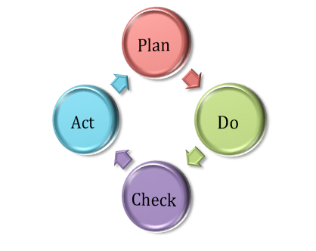
This is a system by which the efforts to improve the quality of service is an on-going process. This approach has many benefits. For example, allow keeping up-to-date with customers changing needs, wants and expectations. It enhances the restaurants performance and keeps the organisation competitive. The CI tool that we recommend is a four-step process (can only be implemented once the restaurant is up and running), put forward by Deming, the PDCA cycle.

Plan
ICT is important in business, it is constantly evolving, and Ms Nok should therefore be continuously examining IT systems in place. To tackle problems of stock-shortages in times of high demand fluctuation (caused by the Super Jumbo), an automated-stock-re-order system should be in place. As soon as the computer recognises the rate of turnover and the amount of stock left, suppliers would receive an automated order request. At this stage, she should also set goals i.e. less that 10% wastage per month, never more than four hours without shelve stock and more than six without other supplies.

Do
Here, data is collected such as turnover patterns during the year and correlation between flight-origins and sales. Data is then analysed and compared to competitors such as Frankie and Benny’s and from this she can see what she is doing well and where she can improve i.e. technology. Operations performance must be measured to determine if the restaurant is performing successfully.
Check
This stage is to assess whether the data collected in the “Do” stage is accurate and if measurement tools are indeed working. If she finds a problem, then she can quickly address the situation in the next stage.
Act
At this stage, Ms Nok must decide on changes to be made in order to keep the restaurant efficient and competitive. Law and ICT are constantly changing, and so, she must be informed about changes in law and ICT. If however, everything seems to be running smoothly, the PDCA cycle is repeated.

2.3 Quality Assessment
Quality assessment is about ensuring operations are working smoothly within an organisation, and there are tools that can be used to do exactly that. In this section, assumptions are made in order to illustrate how quality can be assessed.
Fish-Bone Diagram
This tool helps identify root-causes of problems. For one particular problem, there may be multiple causes. Figure one assumes that customer complaints have gone up by 15% (that is the problem) in the restaurant. The branches coming off the horizontal line represents the most likely causes that led to an increase in complaints.
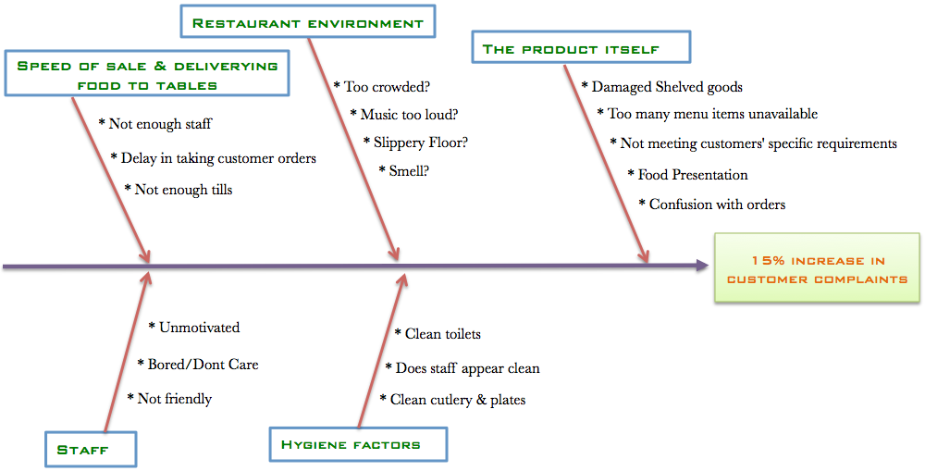
Figure 1

Flowcharts
Why why why
QC

Cutlery

An efficient and effective way to tackle process or quality improvement is through teamwork. However,
people will not engage in improvement activities without commitment and recognition from the
organisation’s leaders, a climate for improvement and a strategy that is implemented thoughtfully and
effectively. The section on People expands on these issues, covering roles within teams, team selection
and development and models for successful teamwork.

Quality is not a desrtination, is a journey

TQM, combined with effective leadership, results in an
organisation doing the right things right, first time.

Management systems are needed in all areas of activity, whether large or small businesses, manufacturing,
service or public sector. A good QMS will:
• Set direction and meet customers’ expectations
• Improve process control
• Reduce wastage
• Lower costs
• Increase market share
• Facilitate training
• Involve staff
• Raise morale

All managers, not just the staff in the "quality department", need to be fully committed to operating an
effective quality management system for all the people within the organisation. The system must be
planned to be effective and achieve its objectives in an uncomplicated way. It should also not be static, but
be flexible, to enable constant seeking of improvements.

Imai warsn that too much stress can be laid on the need to learn the techniques. He believes that most quality poroblems can be resolved by simple steps using common sense.

Appendices
How Ms Nok can develop a relationship with customers by looking at small details.

- Well lit, clean, comfortable chairs and tables
- Appropriate investment on glasses, plates and cutlery so as to impress the customer
- Customers must perceive that staff members as friendly. Moods and attitudes of staff can affect those of the customer.
- Staff must be shaven, short hair, nails clipped, make up to a minimum, no funky hairstyles, clean and ironed clothes, comfortable and smart shoes, and minimum jewellery.
- A menu that appeal to all customers, particularly those from America, EU and Japan. All food, from snacks to three course meals must be at an affordable price and exceed quality expectations. Customer must perceive value for money.

