1.0 Power
Power within ‘Quick Cuisine’ was a foremost issue. The interaction between the political activities and the power structure is demonstrated within the organization. We find that the general assistant complains about one another to the duty manager, who listens and then says something will be done about it but they usually seem to forget. This shows that power struggle between individuals can be confined by the power structure represented by the hierarchy’s. The duty manager may use the cognitive theory.
“A leader cognitive ability contributes to the performance of the team only when the leaders approach is directive”
(changingminds.org, [YEAR])
Duty managers manager must work to improve their skills at planning and decision-making, in order for their plans and decisions to be implemented.
There is an issue of commitment to the job. For example, GA Sita arrives late to work very frequently, and Archie (manager) has not taken action to solve the problem, because Hortense has not informed him. So the problem goes on.
As a supervisor, it is Hortense’s duty to inform Archie of employees who repeatedly arrive late. Hortense needs to understand the position she is in and the power she has over her subordinates. Even if they are her friends, all general assistants need to be treated fairly (Andrew Kakabadse and Christopher Parker, 1984).

French and Ravens theory [YEAR] explains that positive and negative control can be distinguished. Positive outcomes may take account of long standing problems brought to the surface can be resolved. In order for Sita to stop arriving late to work, Hortensee will have to take action. This will remind Sita of Hortense’s hierarchical position within the organisation, and prevent her from breaking organisational policy.

2.0 Individual Differences, Perception and Conflict, and learning styles
Solving organisational problems at Quick Cuisine (QC) will bring down conflict to an optimal level and increase motivation.
Appendix 1 has a table, which shows what is going good and what going bad at quick cuisine and what could be improved. Rows highlighted in orange are serious situations that will be discussed.
In this report, the Interactionist Frame of Reference on Conflict is assumed, as the authors believe that a certain level of conflict is positive for the development of the organisation. Figure 1 shows three different levels of conflict in relation to organisational performance. Too much conflict (3, too great) means organisational performance is low. This is where QC finds itself at the moment. The conflict level must move to level 2, the optimal level where organisational performance is high.
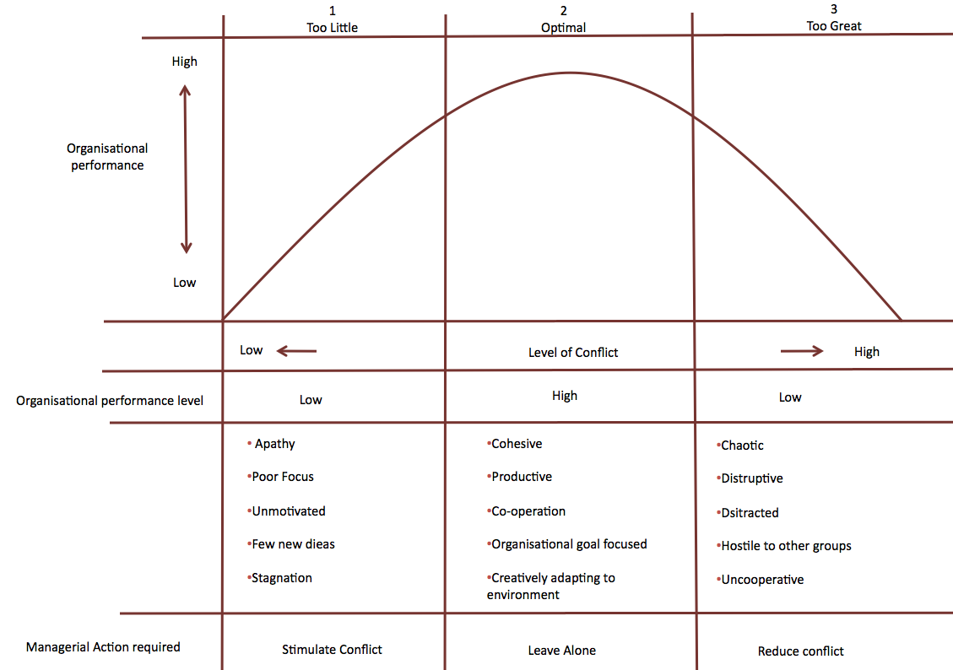
Figure 1

Adopted from: Huczynski and Buchanan, 2007
Process theory can aid to approach organisational problems and identify solutions. Process theory is effective because, unlike variance theory, it helps identify the effect of unfolding inter-connected events (Mohr, 1982), as shown in figure 2. The following are some of the points put forward by Mohr (1982). These will help understand:
- Messy social and organisational events
- Which are affected by a large number of different factors
- Which do not have independent effects, but combine and interact
(Huczynski and Buchanan, 2007)

Figure 2 shows a chain of events at Quick Cuisine that are all connected and lead to unmotivated workforce and conflict. This has a negative effect on the communication between management and staff. In order to be a good manager, one must have good communication. Figure 1 identifies communication as a source of problems. Communication at QC must improve to avoid unnecessary misunderstandings, bring conflict down to an optimal level and increase motivation.

Figure 2
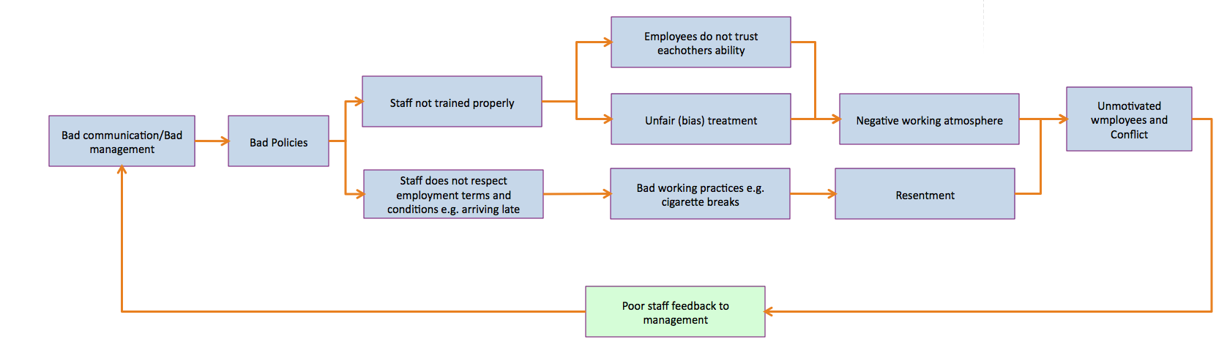
Some employees do not like the colour of the uniform because they perceive “it makes them look sick”. However, Archie’s perception might be that that the colour green is adequate to i.e. the premises.
“It would make little sense to ask whose perception is correct”.
(Huczynski and Buchanan, 2007, p.216)

Archie’s objection to changing the uniform colour undoubtedly leads to an unsatisfied workforce. Archie is aware that staff does not like the colour but he chooses to ignore their opinions, a rather autocratic approach. This creates conflict between the management and the staff.
The solution to this problem is to listen to what employees need. If they are unhappy with something, Archie should do something about it. Perhaps, Archie can adopt a democratic approach by swapping the green to a colour they prefer. This would have a great impact on the workforce, as they will perceive that Archie is concerned about their needs and wants, which will then develop closer relationships with management.

There is also a lot of conflict between employees. For example, permanent general assistants (GA’s) feel like they know better than temporary GA’s, and problems usually occurs when they work together. This is because Archie does not train staff properly and expects them “to pick things up as they go along”. Furthermore, it is evident that Hortense did not receive training in people management when she got promoted. She is perceived as being bias towards some GAs, and that should not be the case. Whilst at work, Hortense must assure that all her line subordinates comply with company policy. For example, if someone arrives late, then this should be recorded, regardless of Hortense’s relationship with the latecomer.
The solution is to provide full training to all new GA’s. The result would be temporary and permanent GA’s trust on each other’s ability when they work together. Permanent GA’s will no longer think temporary GAs can’t be trusted. This will reduce conflict between employees, and develop a better working atmosphere for everyone, which in turn increases the quality of communication amongst staff. Also, Hortense and duty managers must receive appropriate and advanced people management training, so they can be more professional, unbiased, an able to deal with employee complaints. Archie must bear in mind that these GA’s are the first line of contact with customers, and they must be highly motivated and enthusiastic, so good customer service is delivered.
The importance of training is stressed, if staff is not trained properly, the outcome can be a grave as the recent NHS case, where a nurse accidentally switched off a patients ventilator, causing brain damage (BBC, 2010).

The problem of employees leaving for cigarette breaks, which causes resentment among non-smokers. Archie can implement a cloaking system. Every time an employee feels like going for a “cigarette break”, they cloak-out, and cloak-in when they come back. The amount of minutes they spent on their cigarette break is taken out their pay cheque. This system can also be used to see who was on time and who was late for their shift. Some employees (smokers) will argue that this is unfair. Archie must explain that they will be not paid to be unproductive during their working hours.

The organisational changes suggested will take time. Archie will find that employees will find it hard to get out of their bad habits. One way for Archie to make sure employees learn to adapt to the changes is to use reinforcement regimes (Huczynski and Buchanan, 2007).
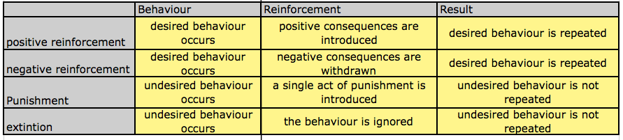
Table 1
Adopted from: Huczynski and Buchanan, 2007
Table 1 shows the different reinforcement regimes that can be used based on the type of employee behaviour. For example, if an employee is late to a shift more than three times in a week, Archie can reduce the number of shifts they get the week after (punishment). If duty managers respond better to employees’ issues, then this would go on their annual review, which can then increase their salary.

3.0 Politics
The division between permanent and temporary staff at QC is evident. Permanent staff spends too much time gossiping and therefore being unproductive. They regard the temporary workers as less reliable than themselves due to having less experience. The political structure sets up boundaries of differentiation between groups, which have an inclusive and exclusive effect, and therefore, a greater chance of communication failure and the development of conflict (Andrew Kakabadse and Christopher Parker, 1984).
The Tuckman theory, [EXPLAIN THE TUCKMAN THEORY BRIEFLY] if applied, may encounter the successive stages of group development within team working as stage one considers the hierarchical structure, pattern of leadership and the individual roles and responsibilities. This leads to reforming arrangements for the working and operation for the group, and agreement on more meaningful structure and procedure. And by reaching the last stage after successful progress, they will have created structure and consistency to work effectively as a team. (Team Working- Tuckman theory). [APPLY TO CASE STUDY…IS TOO GENERAL, YOU NEED TO ADVICE ARCHIE……IT READS AS IF YOU JUST COPIED IT FROM A BOOK]

4.0 Structure
The effects caused by the organizational structure are lead to bad decision-making. Hortense treatment towards the temporary workers is very unreasonable; she gives awkward tasks to those who are not her friends, and informs Archie, only about those latecomers who not her friend. This shows that the structure is not performing as it should. Duty managers should make sure Hortense is doing her job properly. However, duty managers do not and that is why Hortense performance, as a supervisor, is poor.
For staff behavioural improvements to be made within the organization there should be the duty manager, who could also take charge in giving out tasks. As there are two duty managers available [EXPLAIN BRIEFLY HOW DOES A DUTY MANAGER GIVING OUT TASKS WILL CHANGE EMPLOYEE BEHAVIOUR].

5.0 Organisational culture
Organisational culture is ‘shared values and beliefs that underlie a company’s identity’. Sometimes, duty managers help the GAs during busy times. This shows that duty managers encourage teamwork across the vertical structure, thus creating better working relations. It is evidence of positive organisational culture as duty managers and the GAs share the similar values and beliefs regarding customer satisfaction (Buelens, et al, 2002).
However, there are few problems in Quick Cuisine regarding organisational culture. Girls used to complain about the colour of their uniforms but managers did not respond to their concerns. According to Rokeach’s definition of ‘values’, QC management did not value the girls’ opinions. This means employees feel they are not valued, and become reluctant to accept overtime shifts.
Archie should aim to improve organisational culture, as it can improve Quick Cuisine’s performance overtime (Whipp, et al, 1989).
It is recommended that duty managers value GAs’ opinions in regards to any concerns they may have. Duty managers should respond to GAs’ concerns rapidly instead of ignoring them. For example, staff complaints about unauthorised cigarette breaks taken by some GAs, which duty managers chose to ignore. This is evidence of organisational culture, which diminishes GAs’ values. This problem can be address using the cloaking system proposed in part 2 of this report.
Organisational culture can only be changed by people, but it has to be demonstrated by senior management (Bate 1995). It is recommended that Archie hold a meeting with all staff and thoroughly explain the new culture at QC, where every employee is valued. Part 2 of this report suggests changing the uniform colour. This would indicate management take employees’ opinions create on board. Thus, taking the first step to create a culture where communication between management and GA’s is effective, and eliminating unnecessary conflict. By the time the Cayley-Hogg’s inspection takes place, QC should have taken the first steps to improvement, which shows his commitment to improving QC performance.

6.0 Teamwork
Quick Cuisine allows their managers lot of freedom in relation to how individual concession is run, and according to Kets de Vries (2001), it is an effective system. He states that successful organisations are made out of good teams. In order to build a good team “organisations need to foster diversity, which entail respect for the individuals” (Kets de Vries, 2001). Quick Cuisine is adopting diversity and respect for managers by offering them freedom, evidence that Quick Cuisine can be successful. However, this can be a problem, as it puts more pressure on Archie to perform, which can be stressful and have negative impact on his motivation, and therefore his productivity.
Tuckman and Jensen (1977) demonstrated that groups develop through five stages. There are shown in Figure 3.
Figure 3
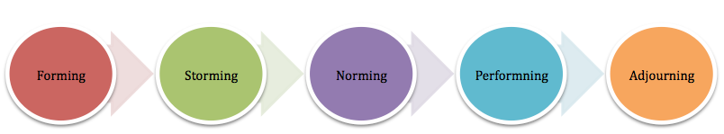
Adopted from Tuckman and Jensen, 1977
According to this model, Quick Cuisine is at the ‘Storming stage’. This is because there is conflict and little communication between permanent and temporary GAs when they together. Archie needs to move his workforce to the ‘Performing stage’, where teams are highly productive and work efficiently. Currently, the gaps between ‘Storming’ and ‘Performing’ are immense.

For Archie’s workforce to achieve ‘Norming’ and ‘Performing’ stages, he should improve organisational communication and provide the necessary training to management and general assistants, as well as responding to their opinions on the uniform colour. Having done this, motivation will increase and a better working atmosphere will be created. Communication will flow better up and down the chain of command, which means management knows what is happening down at the bottom of the structure, and GA’s know management future prospective. No secrets and no lies will develop close working relations. When management keeps information from staff problems arise because staff does not know everything they need to know to perform properly.
According to Belbin (1997), group members must undertake different roles within a team; these will depend on individual’s personalities, characteristics and also their position within the organisation. For instance, Archie is the ‘Co-ordinator’ and the ‘Monitor-Evaluator’ because he delegates well. The assistant manager can be the ‘Resource Investigator’, duty managers can be the ‘Implementers’ and ‘Planters’, the GAs are the ‘Completers’ and ‘Team Workers’. These roles have been allocated according to Quick Cuisine’s organisational structure, and are recommend to Archie to follow because this is the most effective way of improving teamwork in short period of time.
To eliminate the division between the temporary and permanent GAs, Archie could send them on teambuilding courses. This would encourage both types of GAs to work together as a unit, and be successful by achieving common goals (Obeng, 1994). Archie only has six weeks to implement these changes; so he must take quick action.

7.0 Motivation
Frederick Herzberg developed the ‘Two Factor Theory of Motivation’. He found that job satisfaction and job dissatisfaction acted independently of each other. He concluded that a certain set of factors cause satisfaction in the workplace while another set of factors cause dissatisfaction [Appendix 1]. Herzberg (1966) proposed a two-step approach to understanding employee motivation and satisfaction. For simplicity, these are shown in table 2, along with the effects of a motivated workforce.
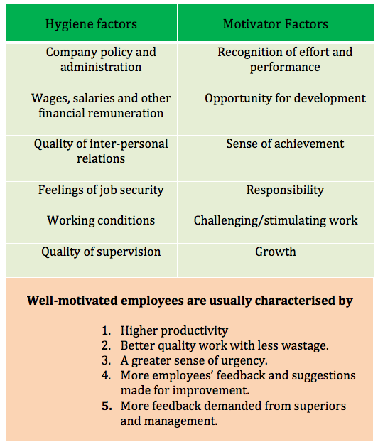
Table 2

Adopted from GCSE Business Studies by Anderson, 1998

Hygiene factors are those aspects of work that have a negative impact on motivation, and are perceived as being unpleasant by employees. Hygiene factors ultimately demotivate the workforce.
At the Quick Cuisine concession, permanent GAs are all paid just above the minimum wage and Hortense, the supervisor, is paid slightly more than the GAs. This addresses the hygiene factor of ‘Wages’; by paying the employees higher than the minimum wage, rather than the minimum legal wage, Archie is succeeding in satisfying employee needs. Archie sometimes enriches GAs duties by getting them help to make sandwiches and driving stock around the site. However, although job enrichment is good, Archie must ensure GAs do not perceive they are being exploited. This may cause dissatisfaction and might lead to staff demanding a pay rise.

Another Hygiene factor is the ‘Quality of Supervision’ - Archie is fulfilling his role well by investigating all written complaints. Nevertheless, there are concerns that the Duty Managers listen to complaints, claim they will do something about it, yet do not. This will frustrate staff further, and will aggravate situations more, which will lead to a low motivated workforce. To avoid disappointing employees, Archie must put into place a new system whereby complaints are dealt with promptly. Duty managers must take their duty seriously. If not, Archie can apply reinforcement regime methods to them as well.

A major inadequate hygiene factor at the concession is ‘Quality of Inter-personal Relations’. There is much conflict between the part-time and full-time staff meaning that the quality of interpersonal relationship is quite poor. Possible ways to improve the quality of relationship may be to arrange social events outside of work hours where staff can have the opportunity to socialise. Also, Archie set up Quality Circles, where employees can share their opinions on how service quality can be improved, and identify sources of quality problems. This is good for the organisation and for staff, as they get to discuss and share ideas.

Hygiene factors only cause dissatisfaction if not addressed. When they are considered adequate, workers will be satisfied with their work; only then can motivators start to have an effect.

Motivator factors are based on an individual's need for personal growth. When they exist, motivator factors actively create job satisfaction. If they are effective, then they can motivate an individual to achieve above-average performance and effort.
Hortense was once a GA but was promoted when the Supervisor post was created. This addresses the motivator factor of ‘Opportunity for Advancement’ and ‘Growth’ as it demonstrates to other GAs that there is an opportunity to be promoted. If these opportunities are advertised more, it can act as a powerful motivator and incentive for employees to work more productively and efficiently.
Archie is described as being ‘extremely ambitious’ and feels he has a great deal of scope to prove he is worthy of promotion. Here is an opportunity to ‘Gain Recognition’ and it can be seen how Archie’s want to feel a ‘Sense of Personal Achievement’ is motivating him to work productively. Being the manager, his motivated approach to work can have a positive influence on employees too.

At the concession, employees are made to work in different units everyday. This type of job rotation avoids boredom and demotivation which, according to Rothlin and Werder (2008), is caused by repetitive, uninteresting, and unchallenging work. The random rotation of employees means that no single individual is left to do particularly uninteresting work constantly. In this case, the ‘Challenging and Stimulating work’ is acting as a motivator factor.

8.0 COMMUNICATION
According to work by Claude Shannon and Warren Weaver (1949), communication involves an exchange of meaning, achieved through the process of coding, transmission, decoding and feedback. Face to face communication allows instant feedback; coding and decoding problems arise with other forms of communication where feedback is delayed or absent.
Archie should therefore plan meetings every fortnight/monthly with all the employees so that feedback can be given and announcements can be made face-to-face. In this way, coding and decoding problems can be avoided. Archie can also enforce office hours so that employees can speak to him in person when needed, or when they wish to make a complaint.
The telephone network on the premises aids communication between concessions and departments. This speeds up operations and has a positive effect on communication. However, the phone network does not seem to work at the ice cream sections. This can be seen as a waste of resource since there is a communication platform, which is not being used. Also, Employees at the tills are not using this network, and would rather leave their positions to go and speak to one of the duty managers. This has a negative effect on customer service. To improve communication, staff should be encouraged to use the telephone network, rather than leaving their positions, and Archie should also have the telephone network at the ice cream department fixed.

To improve overall communication within the concession, Archie should aim for a more open climate; a supportive climate that is solution-orientated, caring, egalitarian, honest, and where feedback is offered regularly. Words must be backed by action; duty managers must act on complaints received rather than just listening and doing nothing about it. Archie must also emphasize the importance of face-to-face communication where possible/appropriate, whilst also encouraging employees to bring both good and bad feedback.

Appendix 1
Good things | Bad things | What can improve
Archie gives fewer hours to those employees whom he is not satisfied with. |  | He should give performance reviews more often and set targets.  He could also make recruiting more strict, so as to select the best candidates.
Uneven balance of the sexes (5 female and 1 male GA’s). | Archie has too much freedom (not necessarily a bad thing, but he only has two years experience). | Archie should justify why there is an uneven balance of such. He should inform the HQ of his decisions, so as to receive advice in order to avoid lawsuits.
 | Training is “offered” not compulsory. Employees “pick what they need to know as they go along”. | Thorough and regular training must be provided to all employees and make sure they know what they are doing from the start. This ensures high levels of customer satisfaction and avoids errors that may harm staff or customers.
Clean set of uniforms is brought each day from local dry cleaners.
 | Some employees don’t like the colour of the uniform because “it makes them look sick”. | Archie could take this into account and consider changing it. This could show he cares about the thoughts and opinions of his workforce.
 | There is a social division between permanent staff and temporary staff. Problems occur when they work together. | Archie must take action and eliminate this division, as it limits workforce productivity.
Archie investigates all written complaints. |  | All complaints must be investigated thoroughly
 | Supervisor (Hortense) is bias towards some employees | She should receive training on people management
 | Smokers take “cigarette breaks” and cause resentment among non-smokers. | Smokers should wait until their break for a cigarette, and it should be stated in their contract of employment. Thus, everyone is treated equally.
 | Employees get frustrated when they hear co-workers are not working as hard | The duty of the supervisor should be to ensure that everyone is pulling their own weight and eliminate “slackers”.
 | Duty managers listen to staff complaints about co-workers but “seem” to do nothing about it. | Duty managers should listen to staff complaints and take action, as well as notify Archie. These complaints are feedback, and feedback improves organisational performance.
There is a telephone network in the premises to aid communication between concessions and departments. This speeds up operations. | For some reason the phone network does not seem to work at the ice scream sections. Also, Employees at the tills are not using this network, and would rather leave their positions to go and speak to one of the duty managers. | Staff should be encouraged to use the telephone network and Archie should consent to them leaving their positions.  Archie should speak to the IT and communication department so that they can fix the telephone network at the ice scream section.

Appendix 2

Herzberg’s Two Factor Theory of Motivation (Herzberg, 1968)
