2.0 Quality Management

Introduction

It has been noted that there is growing number of EU, American and Japanese tourist in The Republic of Nostovia, and they make significant contribution to the national economy.
Massaki Imai, the founder of a global management and executive recruiting firm, “warns that too much stress can be laid on the need to learn the techniques. He believes that simple steps using common sense can resolve 90% of quality problems”. Therefore simple, straightforward approaches will be outlined and recommended to Ms Nok. If quality management is made to complex, quality suffers.

2.1 Total Quality Management (TQM)
TQM is a management concept put forward by W. Edwards Deming. By applying this concept, errors in the provision of services are reduced significantly.
“TQM is a long term strategy. The aim is to continuously improve the product or service, and this is known as Keizen”
(Hollins and Shinkins, 2006, p152)

Once the restaurant starts its operations, Ms Nok should not expect overnight improvements by applying the recommended quality management procedures. The following table outlines two approaches to quality management. A recommendation as to which is recommended will follow.
Box 1
International Standard Organisation 9000 | PDCA (or Deming Wheel)
This quality management approach was introduced in 1987 and puts forward a model for managing quality. Recent series of the ISO 9000 are also applicable to the service sector. This model is “process-based quality management system”. The ISO 9000 has eight principles that ensure high levels of customer satisfaction, see appendix 1.  These principles are:  - Customer focus  - Leadership  - Involvement of people  - Process approach  - System approach to management  - Continual improvement  - Factual approach to decision making  - Mutually beneficial supplier relations  Figure 1 shows how the main provisions of the ISO 9000 (box 2) work together in a process, which “converts customer requirements into both products and customer satisfaction” (John Nylor 2002). This process is a cycle that Ms Nok will repeat time and time again, so as to sustain high customer service and guarantee quality. | W. Edwards Deming developed the PDCA model (figure 2) approach to improving quality, “Credited to Walter Shewhart in 1931” (Hollins and Shinkins 2006).  PDCA stands for Plan, Do, Check and Act.  Plan – here, an operational process is designed or revised i.e. Standard communication network with suppliers.  Do – The plan is implemented, and then it is measured and its performance is analyzed.  Check – measurements are reviewed in order to identify what is good and what is bad about the process i.e. software keeps failing. These reviews are then sent to Ms Nok to make informed decisions.  Do – Ms Nok will decide what changes will be made to the process i.e. up-grade ICT systems or bring in technicians to fix the problems. If everything seems to be going well, the PDCA cycle is repeated.

2.2 PDCA Cycle

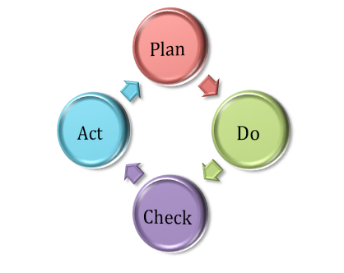
Figure 2

Adapted from Managing Service Operations, design and implementation,
by Bill Hollins and Sadie Shinkins, 2006

Plan
Ms Nok could consider and design an approach to Just In Time system (discussed earlier in the report). However, she must bear in mind that JIT will only work for restaurant orders. Shelve goods such as drinks and crisps, and ingredients such as rice and condiments, would have to be ordered in bulk way in advance.
Do
If she finds that she would like to apply the JIT system in a particular way, this is the stage where she does it. She keeps records to later review these and measure performance.
Check
Ms Nok will assess the data collected in the “Do” stage and check if it is accurate. Performance of this new system will be inspected for faults.

Act
If the system has problems, Ms Nok must decide on changes to be made, or to drop this approach to the system. If the system performs fine, the cycle repeats itself.

2.3 ISO 9000
It is recommended, however, that Ms Nok uses the ISO 9000 approach. This is because the PDCA cycle can seem very simple. It often oversimplifies processes and misses important stages that are critical for continuous improvement. The ISO 9000 are a set of quality standards that would allow Ms Nok to ensure quality levels meet a certain criteria. Box 2 shows the provisions of the ISO 9000in relation to Ms Nok’s situation.

Box 2 – ISO Provisions, applied to Ms Nok
Quality management – Ms Nok will establish and implement a quality management system i.e. Virtuous cycles in quality improvement. This system must be documented properly and continuously improved.
Management responsibility – Ms Nok as the manager of the branch, should provide evidence of her commitment to ensuring and continuously improve quality of service. Establishing policy that has a focus on customer satisfaction would ensure employees know the mission of the organisation.
Resource management – Staff should be appropriately trained and they should be given the required equipment to do their job properly. Their work environment should be up to Health and Safety standards so as to ensure their work safety as well as the quality of the service provided within the premise.
Service realisation – all services and products sold within the restaurant should focus on meeting customers needs and wants, as well as their expectations. Origins of ingredients and other supplies must be to the specific requirements and traceable, and all suppliers must agree with these terms.
Measurement, analysis and improvement – Ms Nok should plan improvements to the operations process. Improvements should be measured, analysed and monitored frequently so as to ensure operations are running smoothly.

Adapted from operations management, second edition, by John Naylor, 2002

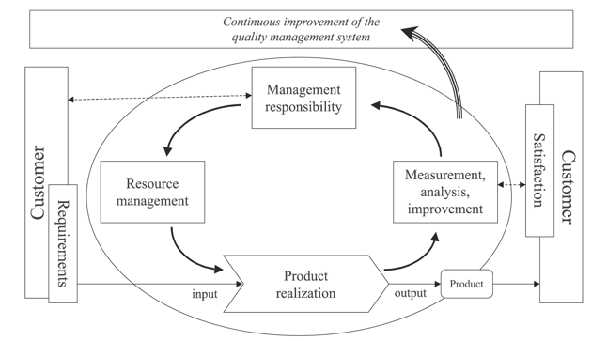
Figure 1 – Process-Based Quality Management System
Adopted from the Economic Control of Quality Manufactured Product, by Walter Shewhart, 1931.

Figure 1 shows how the main provisions of the ISO 9000 work together in a continuous cycle, and points out the importance of setting-up customer-focused policies. It is a two way process, Ms Nok ensures all staff commits to providing good customer service, whilst customer feedback can then help her improve policies without putting too much pressure on staff.
When identifying key customer requirements, Ms Nok should consider the four performance objectives. These are quality (providing services without error. And ensuring customer satisfaction), speed (customers should not wait for longer than 10 minutes for restaurant orders), dependability (if customers are told the orange juice is 100% pure, it should be), flexibility (preparing food to specific customer requirements i.e. big difference between medium-rare and a well-done stake). All of this forms the input towards product realisation, where the product is prepared/produced and made available to customers. Once the product has been made available, the next stage is to measure and analyse the operations.

If analysis indicates that customers are not satisfied, and/or service quality is not meeting standards, then the next stage in the cycle is a quality management system. This is referred to as “quality assessment”. It identifies the problem, tracks the source and provides a solution to the problem.

2.4 Quality Assessment
Quality assessment is about ensuring operations are working smoothly within an organisation. In this section, we assume that the restaurant is up and running.
Fishbone or Ishikawa Diagram | Why-why Analysis | Quality Circles (QC)
This tool helps identify root-causes of problems. For one particular problem, there may be multiple causes. Figure 3 assumes that customer complaints have gone up by 15%. The branches coming off the horizontal line belong to a category i.e. environment, and policies. These categories have aspects, which in turn, may be responsible for the problem. | Similar to the fishbone diagram, this is a structured tool identifies root-causes of problems at Ms Nok’s restaurant. It works by stating the problem and asks “why” it occurred, and it follows up each major possible reason. The process goes on until there are no more answers for “why” it occurred. Figure 4 illustrates this principle and assumes that the problem at Ms Nok’s restaurant is unsatisfied clients. | Quality circles are groups that gather to discuss quality and quality control problems at work, and how it can be improved. Ms Nok must bear these principles in mind.  1 – Employees must volunteer. This makes use of staff that is concern with quality.  2 – Employees must receive training on quality control approaches and problem solving  3 – Ms Nok, as the leader, must be able to direct discussions and encourage everyone to contribute.  4 – Ms Nok must take their suggestions into account and try them out. Otherwise, employees will just stop coming because she does not put their suggestions into practice.

Fish-Bone or Ishikawa Diagram
Categories used in the service sector tend to be policies, procedures and people.
(Hollins and Shinkins, 2006, 164)

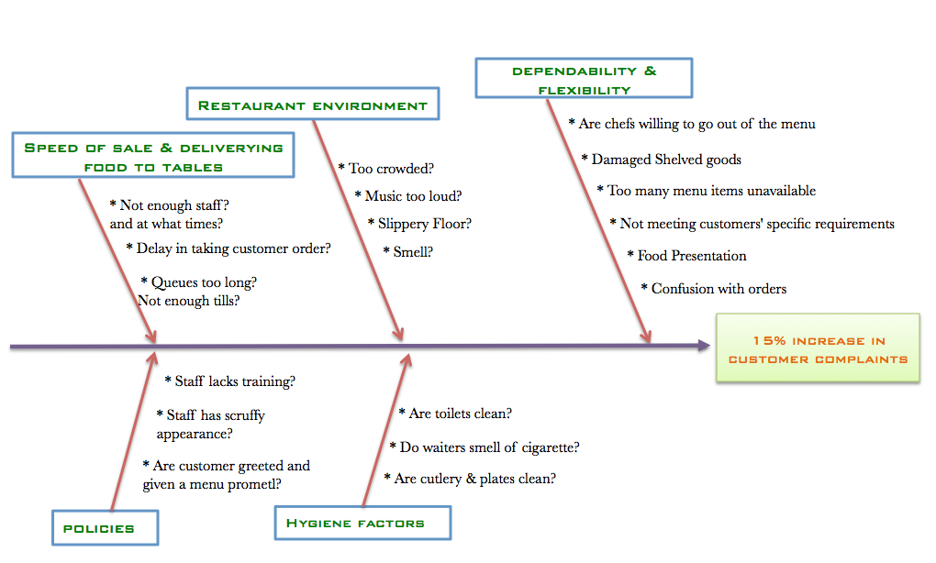
Figure 3

After having drawn this diagram, Ms Nok can go through each of the possible causes and check which of these is causing customers to complaint. For each problem there will be different “suspected causes”. For example, if there is too much wastage, would that be because of the life-time of the product, or how its handled, or storage or delivered.

Why-Why Analysis
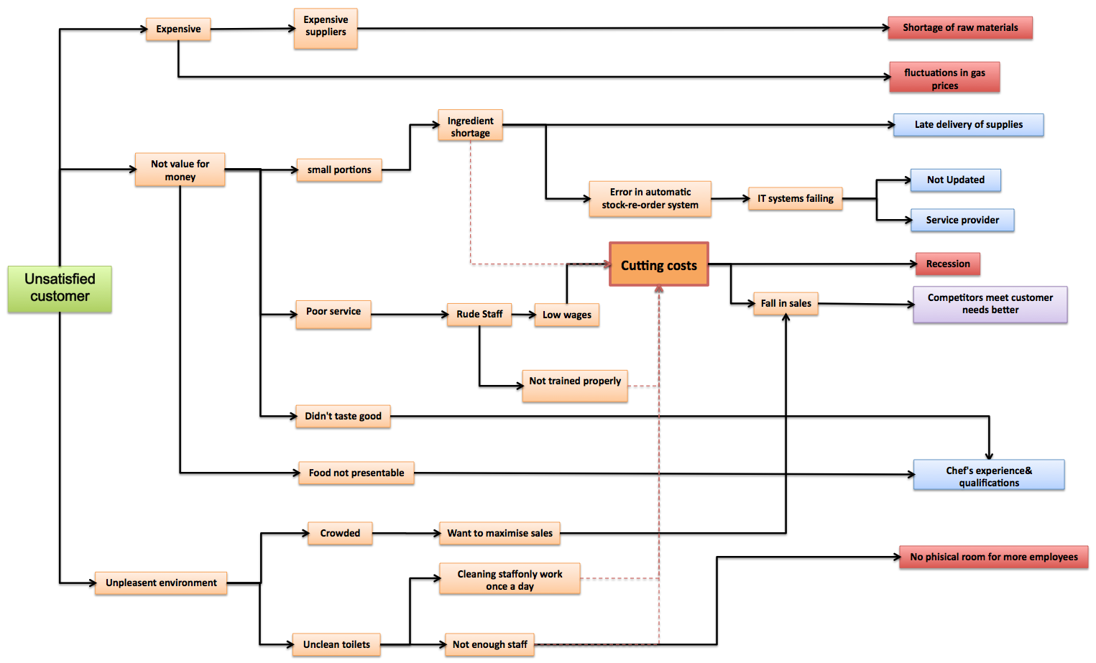
Figure 4

It is recommended that Ms Nok use of the why-why analysis for assessing quality. This is because fishbone diagrams allow for too many possible causes for a particular problem. Quality circles consist of motivating employees to take part in discussions. Most of the time, employees do not see that as their responsibility because they are not getting paid extra. Furthermore, quality circles do not establish the main possible causes. This is the reason why it is recommended that Ms Nok use the why-why analysis. It identifies the best possible causes for a problem, and unlike a fishbone diagram, these are not too many. This tool makes identifying a solution for the problem much faster than the other two options.
The red boxes at the end of the diagram in figure 4 are causes, which Ms Nok cannot control (i.e. recession), and thus, she must be flexible. Blue boxes represent possible causes that she can control, and can eradicate to solve the problem. The purple box shows something that she cannot control, but can be affected by improving customer satisfaction (drawing customers from competitors).
The diagram also shows that “cutting costs” seems to be the cause of certain operations failures. As a result sales are falling and competitors are benefiting. Dashed lines suggest a possible link. For example, there might be an ingredient shortage because of possible cost cuts.

Appendix 1
1 – Customer Focus
Placing the customer at the centre of all operations. Market research will identify customers’ needs, wants and expectations. These have a significant influence on the restaurant’s objectives. Customer satisfaction must be measured (i.e. if customers expect their food within 10 minutes, number of times these expectations are not met must be quantified), and prompt action on the results is crucial.
2 – Leadership
MS Nok must know the needs and wants of her workforce, to satisfy them and motivate them. Employees should know the restaurant’s goals and objectives, as well as future prospects. Ms Nok must recognise their commitment and effort and praise. Invest on training and provide opportunity for career development, as well as setting challenging targets.
3 – Involvement of People
Ms Nok must ensure that employees understand the importance of their contribution in the restaurant. Ms Nok should encourage employees to accept ownership of mistakes and take on responsibility towards solving these. Employees should also be encouraged to seek opportunities for development i.e. chase a oromotion.
4 – Process Approach
Ms Nok should give or delegate clear responsibilities for managing certain operational aspects i.e. Stock Counting. and Stock levels. She must always consider risks and impact on suppliers and customers, before any decision is made, and evaluate benefits and drawbacks i.e. cancelling orders or changing suppliers.

5 – System Approach to Management
Ms Nok must provide clear roles and responsibilities and make sure these are understood so as to achieve common objectives. A system such as Quality Circles can aid achieving objectives. However, QC’s can only be applied once the restaurant is up and running, and improved through “measurement and evaluation”.
6 – Continual Improvement
Ms Nok must provide the training and tools required to continuously improve the level of service quality. Whenever improvement has been made, she must recognise it and praise, and establish a system to measure improvement such as reduced queuing time.
7 - Factual approach to Decision Making
Ms Nok must be able to rely on the data and information collected i.e. speed of service, average queuing time, reliability of communication systems, and frequency of damaged ingredients from suppliers. Such data must be accessible to those who require it such as HQ. Operational decision must be based on facts and not guesses.
8 - Mutually Beneficial Supplier Relationships
Ms Nok must prioritise those suppliers who are most flexible in their working hours and want a long-term relationship. Communication must be clear and fast i.e. using the same ICT packages. She must encourage and recognise suppliers’ development, such as implementation of IT systems to improve on delivery delays and damaged goods.

