Overview of the chosen adverts
The range of adverts collected to analyse the alcohol industry in the UK are from media (communication vehicles) such as billboards, newspapers, and magazines. However, this report will also discuss television media advertising and use screenshots of TV commercials to illustrate discussions where appropriate.
Basic research points that the alcohol industry in the UK makes use of extensive media to remain competitive and increase consumption. In most cases, firms that make up the alcohol industry in the UK use the same media for marketing activities. However, even though these firms share similar objectives, the way in which they use media completely different, and thus, their advertising is different from one anther. For example, Absolut Vodka may use creative artwork on billboards to reposition itself in the market whilst Smirnoff Vodka may use it to sustain its position in the market.
The themes used by each firm in the alcohol industry to advertise their product varies and depends on the market they are trying to appeal. For example, themes may vary from humour, sex appeal, social class, “party animal”, artistic amongst others. It is important for firms within this industry to match the right theme to the right market. For example, Absolute vodka carried out a campaign targeting women that appeared in a Sex and the City episode.
Image 1
Absolut Vodka took the theme to its very limits, matching the right theme (sex appeal) to the right segment (Sex and the City viewers, mainly women) to the right place (the Sex and the City series). Image 1 is a billboard version of the TV ad.

Targeting
Once firms have identified potential market segments, the next thing to focus resources on is targeting. Targeting is simply the step in which firms evaluate the attractiveness of each segment and decide which of these can offer the optimum return on capital invested (Solomon, et al. 2009).
There are many potential segments out there that firms in the alcohol industry would like to target, but some of these are not viable due to numerous reasons. For example, underage alcohol consumers are a segment of an estimated size of 39% of boys and 33% of girls aged 15 to16 (BBC, 2001). Firms in the alcohol industry cannot target this segment because it is against the law for under 18’s to drink alcohol (in the UK) and thus, illegal to target advertising at them. This segment is therefore not viable and must be given no further consideration.
Evaluating a target segment involves many factors that firms in the alcohol industry should take into account when targeting a product or a marketing campaign. For example, are customers in a segment similar to each other (do they have similar needs and wants)? Is the segment measurable? Is the segment large enough to be profitable now and in the future? (Solomon, et al. 2009). Details of these factors and other theory are off the scope of this section. There is rather a focus on how firms in the alcohol industry apply marketing theory.

Segment Profile & Targeting Strategies
Once potential target segments have been evaluated, firms should end up with a few potential viable segments that meet the evaluation criteria. These segments must now be given a “profile”; marketers often refer to the process as profile segmentation. Profile segmentation allows firms to get a better understand the needs and wants of segments. With this information, marketers can appeal to the target segment successfully.
A segment profile is made out of variables, such as demographics, psychographics, life style and purchase frequency data. Table 1 is a simple example of segment profile that firms in the alcohol industry can build using these variables.
Profile Segmentation Variables | Product | Stella | Champagne | Absolut Vodka
Gender |  | Male | Male/female | Male/female
Age |  | 18-50 | 30-50 | 20-35
Earning |  | Over 15000 | Over 35000 | Over 20000
Life Style |  | Modern/social drinkers | Modern | Social Drinkers
Generation (X/Y) |  | X + Y | X | Y
Table 1 (example only, figures not accurate)

Once a firm has established profiles for the chosen segments, it must decide on the appropriate targeting strategy to reach and communicate to these segments. There are four types of targeting strategies, undifferentiated marketing, differentiated marketing, concentrated marketing and customised marketing. Table 2 gives some detail of these different approaches. Examples of how these are seen in the Alcohol industry follow table 2.

Undifferentiated marketing | Differentiated marketing | Concentrated marketing | Customised marketing
This strategy ignores basic market segmentation in order to appeal to a broad spectrum of people through mass advertising and distribution, and thus (if this successful) production, promotion and research costs would benefit from economies of scale (Solomon, et al. 2009). This strategy is cheaper and less time consuming than devising marketing strategy for numerous segments. In the alcohol industry, undifferentiated marketing can be seen in Beer. Beer is a product that is aimed mainly at (western/westernised) men, things like demographics and lifestyle do not really affect the frequency at which males drink beer. In 2007 the UK male population reached 29.9 million, and therefore a very large market to target. Since the potential market for beer male drinkers is so big, why split it into small segments? Why not just target all men? (undifferentiated marketing). | This marketing strategy focuses on targeting one or multiple products to a variety of segments, each with different needs and wants. This requires each marketing strategy to be carefully tailored to each the specific segment. Segment profile variables are essential at this point because each segment will respond to different marketing activities e.g. the message encoded in a TV or Billboard ads. The appropriate use of segment profiles will maximise attention and interest in order to encourage desire and action (AIDA). | This strategy focuses on developing a product (or products) that is marketed at a very specific segment of the consumer population. Marketers following this strategy will commit resources to ensure that the needs and wants of this segment are satisfied. The message encoded in marketing campaigns will be devised carefully so as to ensure the target segment understands the message being transmitted. An example of a firm in the alcohol industry that can be said to use concentrated marketing is Baileys. | This marketing strategy involves focusing marketing activities on targeting a specialised, prestigious or rare product to specific customers. Thus, the target segments tends to be small but lucrative. Companies that target such segments also rely on “pull” market strategies. Pull marketing strategy is where the product is highly demanded by the customers because they know, and in most cases, are familiar with the product. The advantage here is that the firm can minimise costs in marketing activities such as advertising. This is the opposite of undifferentiated marketing, where firms “push” the product into the market.
Table 2

Undifferentiated Marketing
Appendix 1, Image 2 is a simple example of how beer brands like Carling targets men. Carling has targeted UK male football fans by establishing a seasonal football event, conveniently called the “Carling Cup”. Carling knows that most men in the UK watch football (and are football fans) whilst drinking beer. So it uses this event to increase exposure of the brand and increase consumption. Although the this type of promotion is targeting football fans, it is still undifferentiated because its targeting men, women would be the other option, but they are traditionally less interested in football or beer.
Differentiated marketing
Absolute Vodka has managed to appeal to a wide array of segments by (cleverly) swapping “Vodka” for words that depict segments and placing them after “Absolut” (similar to Absolute in English) in advertising. Appendix 1, images 3 and 4 are examples of how Absolut Vodka has appealed to so many segments.
Image 3 is a clear example of how Absolute Vodka is targeting iPhone users (Absolute iPhone). Image 4 targets those who like to club and drink. It actually impersonates the Absolut Vodka bottle and places it at a bar. The different clothes (colourful, casual and funky) clearly suggest Absolut Vodka is for everyone that likes to go clubbing.
Concentrated Marketing
Appendix 1, Image 5 is a screenshot of a Baileys TV ad, in which a man walks in to a bar, the lights go off and a girl kisses him. When the lights go back on he can taste something in his lips (Baileys) and he then looks at a lady (late 20s early 30s, sophisticated, attractive, confident and in control) who is drinking Baileys. So the ad could be saying that women are more attractive if they drink Baileys. This Baileys ad is targeting women that are confident, social drinkers, maybe single, mentally mature, with income of over £25000 and non-clubbers. The full ad can be see at http://wn.com/Bailey's_Commercial_Coffee.

Custom marketing
Appendix 1, image 6 is an advert of Henri IV Dudognon Heritage Cognac. The advert is simple, no words, it just shows the bottle of cognac and its packaging. It is just a simple remainder of how prestigious this 50-year-old bottle of cognac is. This particular bottle is priced at $2,000,000. Thus, mainly aimed at very few wealthy individuals.

Positioning
Once the segment, and the target strategies have been selected, the next stage is to decide how the firm wants to position its product within a segment. Positioning refers to how customers feel about a particular product, how they perceive it (positively, negatively, expensive, cheap, good quality, poor quality, and durability) and their believes on its features and benefits in comparison to similar product offered by competitors.
Marketers will achieve their desired product positioning through the implementation of a carefully designed marketing mix. There are four main steps used to develop a positioning strategy, these are outlined in table 3.
1 – analyse competitors’ positions | 2 - Offer a product with a competitive advantage | 3 - match elements of the marketing mix to the selected segment | 4 – evaluate the target market’s response and modify strategies if needed
If a firm wants to launch a new beer in the market, then it should consider every competitor (brand) that sell beer. It should then identify where in the market have competitors positioned their brands and lastly, the state of the market (e.g. is it growing or shrinking?). | This step is all about offering developing a product with a competitive advantage (a Unique Selling Point) that differentiates it from those of competitors. This competitive advantage should make customers desire the product and give customers a reason why they should buy it instead of competitor goods. | This step involves having all the P’s mixed correctly and these must match the selected segment. This means that the good must consist of the benefits needed and desired by the segment (market orientated). | This stage is all about evaluating the response of customers to marketing activities, and identify whether marketing activity drew customers attention and made customers have an interest in the product. Overtime, it is likely that marketers find that it may be better to target a completely different segment (perhaps due to market changes) and adapt their marketing strategy to the way that new segment perceives the brand. This is called repositioning and usually takes place when a brand is reaching or has reached the decline stage in the product life cycle.
Table - 3
Analysis of competitors’ positioning
Figure 1 is an example of the market positioning of some of the many beers sold in the UK. Marketers thinking about introducing a new beer would have to do something similar (in a larger scale) and decide where it wants to be. For example, does it want its beer to be perceived as high price, low quality like Fosters and Coors light, or low cost and high quality like Carlsberg and Carling, or high price and high quality like Peroni and Guinness?
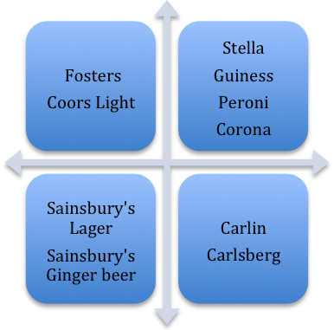Figure 1
Low Price
High Price
Low Quality
High Quality

Offering a product with a competitive advantage
A firm that has chosen its desired market positioning must think about the features of the beer that makes it better than competitor brands e.g. fruity flavour, stays oxygenated for longer, smooth and not bitter etc. Marketing campaigns must emphasise this USP so that it is understood by the target audience/segment.

Match elements of the marketing mix to the selected segment
Here, the beer must be exactly what customers want. The price has to be selected carefully. If the price of a beer is too high customers may think it is too expensive, if too cheap customers may perceive the beer being of low quality (The price set also affects the positioning of the brand). Also, the beer must be available in places that customers are likely to go such as supermarkets, shops, pubs and bars, and be promoted (advertised) in places that the target segment is easily reached, such as bus stops, newspapers and magazines, half-time football commercials.
Evaluate the target market’s response and modify strategies
If a firm that has just launched a beer into the market notices that a completely different type of customers are drinking the beer, it would be sensible to reposition the product and target marketing activity to these customers instead. This is exactly what Lucozade did in order to maintain sales and increase and extend product life cycle. Lucozade’s target market was no longer profitable but so it decided to change Lucozade’s image and target a segment with an interest in sports and fitness.
Critique and recommendations
Appendix 1

Image 2

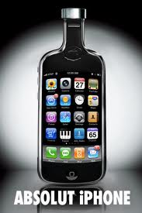
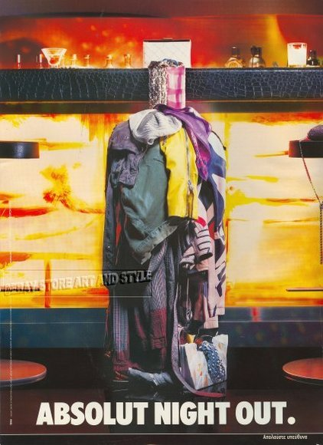
Image 3 Image 4

Image 5

Image 6
