
Authors:Anna Tsvetkova – 11794558
Caroline Herzig – 13068497
Jesse Estes – 12251681
Marcelo Bayas – 11748416
Tanu Jain – 12233733

Tutor: Stuart McNaughton

Module Code: 4MBS551

Module: Global Markets
08
Fall
China - A New Economic Era

Contents

Introduction 3
Executive Summary 4
1.0 PEST Analysis 5
1.1 Political 5
1.2 Economy 6
1.3 Social 7
1.4 Technological 8
2.0 SWOT Analysis 9
2.1 Strengths 9
2.2 Weaknesses 9
2.3 Opportunities 11
2.4 Threats 11
3.0 Chinas participation in the WTO 14
3.1 China’s Contribution to Globalisation 15
3.2 China’s Geopolitical Role 16
4.0 China 18
5.0 Reforms and Sustaining Growth 19
References 22

Introduction

Executive Summary
1.0 PEST Analysis
China is one of the most diverse countries in the world. Sieren (2007) highlights the diversity of several paradoxical combinations that exist in China today. One can see macro-economic stability and social chaos, economic upswings and high corruption, dictatorship and freedom, all of it at the same time.
1.1 Political
Western observers and critics say China is still a highly centralised country with a lack of political will to decentralise. However, evidence of decentralization in China is the Fiscal System. Before 1978 this system was very centralised.

“Unified control over revenue and expenditure was exercised in public finance”
(Yang Zhi-gang, 2001 p.1)

Of course, this system hindered economic development and in 1978, China opted for a reform, which will transform its current economy into a market economy. This reform gradually broke down the centralised fiscal system.

China is needs more political transparency and accountability. For example, the weak legal system fails to take action towards financial institutions with a trail of non-performing loans and bad assets that burden the economy. The economy in general is highly politicised. Controlled by small and powerful groups, involved with political and economic leaders. Thus corruption displays a severe problem (Naughton, 2007). Another intensely debated point is the treatment of political dissidents that are vigorously persecuted when questioning the power of the party. About 4,000 members of the opposition are executed every year according to Sieren (2007).

1.2 Economy
China can enjoy its new status as the world’s second largest economy, after the United States (The Economist, 2010). In the last twenty years the country has observed an enormous GDP growth. Trading Economics say China’s annual GDP growth from 1989 to 2010 adds up to 9.3 % on average, equivalent to 7.92% of the world economy.

In comparison to other nations, China’s industrial share is extremely high, as it has emerged as a favoured site for specific types of manufacturing worldwide (Naughton, 2007). Foreign investors have to deal with a system that can be described in terms of being a ‘concubine economy’. This means that companies from abroad are forced to form joint venture companies with a Chinese parent company if they wish to expand their operations into China. This system is one of many barriers that foreign companies have when they think about expanding into the Chinese market. Having a Chinese parent company would mean different organisational culture, structure, strategy, and fewer profits for the entering company. This is a problem for foreign investors, since their aim is to maximize profits and stay in control of much of what they do.

1.3 Social
China’s population has run trough immense changes in the last decades, such as the shift of thousands of citizens out of poverty or near poverty. According to Sieren (2007), China’s huge population represents, on one hand a great potential, but on the other hand it’s mightiest curse. Even today, the state cannot develop and establish a social system that can provide its habitants the minimum standards of nutrition, medical care, education and life style.

Additionally the gap between urban and rural population has widened in the last few years. The urban income per capita increased 8.8 per cent from a year earlier to 17,175 Yuan ($2,514). In contrast, the rural population (which makes up two thirds of the total population) income per capita increased 0.6 per cent to 5,153 Yuan. Today, the Chinese society is significantly unequal in comparison to other Asian developing countries, with respect to an increased Gini coefficient of 2.64:1 in 2008 from 1.53:1 in 1985 (Yimeng Liu, 2010).

China’s One-Child Policy has always been a controversial topic and has led to dramatic gender imbalances due to the preference of sons. It goes without saying that in the near future policy makers will have to cope with the consequences of an ageing society with a high number of retirees.

1.4 Technological
China has made rapid technological developments and can profit from an explosion of FDI into the country. Within a very short time it has become the predominant source of technological inflows. Nowadays China produces more laptops, computer parts, or mobile phones and other communications goods than any other country in the world. Wang Guanqun (2009) said the Chinese government would support eleven national research programs (carried out by companies, universities and research institutes) with 62.8 billion Yuan ($9.2 billion) to achieve breakthroughs in key technology fields, with their own intellectual property rights.

Such research programs range from a new generation of wireless broadband, to aircrafts, and from advanced nuclear power stations to new drug development and treatment of major infectious diseases such as HIV/AIDS.

2.0 SWOT Analysis

2.1 Strengths
Undoubtedly, one of China’s key strengths is its population, representing a relatively cheap labour force from which the state benefits, as it attracts FDI. World producers and manufacturers are to some degree dependent on China. This is because China offers low-cost production and labour, as well as stability, due to its high production possibility frontier. Therefore, China “pulls” (investors want to enter China) FDI, as opposed to asking or requesting it (“push”). This market force strategy is not only the result of China’s population and cheap labour, but also many other factors, such as those discussed in part 2.0 of this report.

Since China “pulls” FDI, it decides the extent to which it wishes to open its market to foreign countries. Stock markets and the financial system are for example protected to a great extent from foreign investors. Additionally China has only minimal foreign debt, as opposed to the US foreign debt of $13 trillion in June 2010 (Kimberly Amadeo, 2010).

2.2 Weaknesses
China’s enormous population may not always be seen in a purely positive way. The country still struggles with building up a social system where everyone is protected. For example, the lack of infrastructure and poor working conditions has led to miners being killed every month due to deficiently secured mineshafts (Sieren, 2007).

Another problem is the highly evident corruption. Many sectors are still subject to government influence and insider groups (Naughton, 2007). Small and medium-sized companies have to face bureaucracy when in need of a credit, as the government would rather lend money to state-backed firms (The Economist, 2010).
A weak legal framework causes unfair treatments of citizens if they are suspected of a transgression. However, what raises more concern is the violation of human rights. The State Department reported major human rights abuses in 2007. The following table outlines some of these.

Table 1 – Human Rights Abuses
Type of Abuse (I think another colour would ne better to read) | Consequence
Unlawful or Politically-Motivated Killings | Several deaths and 18 Uighur Muslims killed in a counter terrorisms raid.
Torture | United nations reported that Falun Gong practitioners accounted for nearly two-thirds of torture victims while in government custody.
Unlawful detention | Between 2003 and 2007, 33,643 people were held for periods longer than allowed by the law.
Censorship | Public speech and discussion, or reporting of controversial topics are strictly forbidden, so as to protect “state security”.  The Government holds absolute control over political content in media, and censors internet sites, radio stations, email and text messaging.
Re-education through Labor (RETL) | People are held in detention for anti-social behaviour, without formal charges or trial. These detentions can last as long as four years.
Adpted from the CRS Report for Congress, 2008

2.3 Opportunities
China has numerous opportunities to carry out thriving and improving its economic development. Backing the private sector would foster smaller companies, which could make a more efficient use of the resources (Sieren, 2007). Furthermore it would be appropriate to push on Chinese privatisation as it has been already delayed too long and hindered China to become a high-functioning market economy (Naughton, 2007).

2.4 Threats
A topic, which is highly evident in the media, is China’s environmental problem, since it has 16 out of the 20 worst polluted cities on the planet according to the World Bank. China defends itself when mentioning that it was still in the midst of its industrialisation process.

Battling for the world’s energy reserves has become more difficult, and this has brought to view a threat to the Chinese development. The reason why these raises concern is because only has 2% of the world’s oil reserves on Chinese territory. The country’s oil consumption is rising faster than any state planner has predicted before, and that means China needs to sustain positive political relationships, particularly with nations with large oil reserves.

In August 2010, it was estimated that China consumed approximately 35.54 million metric tons of oil, a 7.6% increase from a previous year (Rigzone, 2010). Figure 1 shows the world’s daily oil consumption by country in 2009, and the percentage increase from 2008.

Figure 1 – World’s daily Oil Consumption by Country

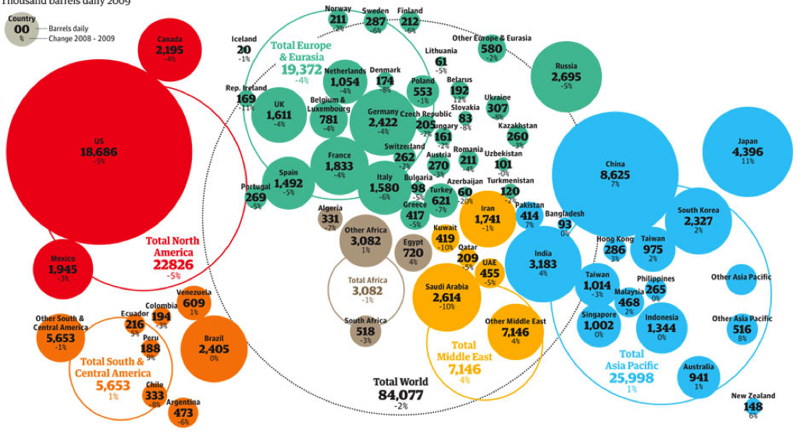

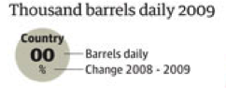

Source: BP energy statistics

3.0 Chinas participation in the WTO

The World Trade Organization is an institution that looks after the rules and regulations of trade between the 153 member nations. Joining the WTO on 11th November 2001 is considered an important event for Chinese economy, and China is now viewed as a valuable member of the global market. Furthermore, joining the WTO has improved the political relationship between China and the United States.

China has moved on from having a centrally planned economy to a market oriented economy in the past 30 years. This can certainly be linked to China’s commitment towards becoming a member of the WTO. The main purpose of WTO is to eliminate barriers of trade between member countries as well as monitoring national trade policies, technical assistance and training for developing countries, administering trade agreements and handling trade disputes. There are many benefits to China joining the World Trade Organization. For example, the WTO’s global system allows trade barriers to be reduced through negotiation, and this means cheaper imports of products used for production. Thus, the cost of production is reduced, which then leads to a fall in prices of finished goods and the provision of services. This ultimately, lowers living costs.

However there are also concerns as to what effect, being a part of the international market, will have on China’s domestic economy, agriculture and manufacturing.

There is some evidence of immediate positive effects of China becoming a member of WTO to its trading partners. In 2002, outbound tourism increased by 37 per cent and businesses started showing interest in investing in China. Availability of cheap workforce, natural resources and high levels of technological innovation has made China particularly attractive to foreign investors.

3.1 China’s Contribution to Globalisation
When talking about China’s contribution to globalization it is important to mention China’s textiles exports and merchandising trade. Table 2 shows China’s contribution towards world’s merchandising trade compared with other countries in WTO. It is clear that China’s exports are valued at 1428.3 billon dollars in 2008, compared to USA which share was one per cent lower than China’s. Germany, China and USA are the biggest contributors to total WTO’s output in merchandising trade. China’s top trading partner is the European Union amounting to the 16.4 per cent share of total China’s Imports and Exports.

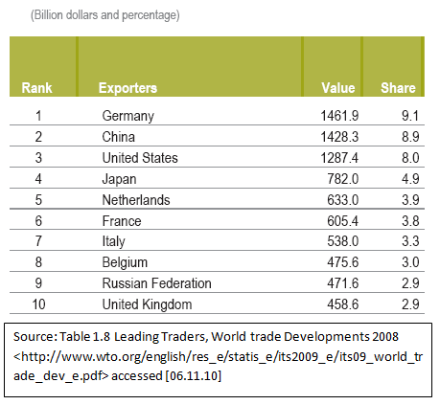
Table 2- Top 10 WTO Exporters by Rank (2008)

Source: World Trade Developments 2008

3.2 China’s Geopolitical Role
As for the Geopolitical role of China on the global market, there has been a shift in global power and China is now a ‘force to be reckoned with’ and some experts are already claiming that China has got economic superpower. From the geographical standpoint, there is a constant debate about whether being surrounded by countries which have close political relationships with the USA could work against China when competing for power on the global market. These countries include Japan, South Korea, Taiwan, the Philippines, Malaysia and Indonesia. China’s availability of natural resources and labour has played a major role in China’s journey towards a more market-oriented economy.

Since the political situation has changed in the past years and Chinese economy keeps growing, China now has opportunities and the means to invest in other countries. Africa is now one of China’s main focuses when it comes to foreign direct investment. China has already helped built infrastructure and extract commercial minerals. Angola is particularly attractive to China because of its oil resources (important to China since they are the second largest oil consumers in the world) and geographical position.

4.0 China

Formerly known as The People’s Republic of China, has been a communist run country since it was founded in 1949. During the 1950s, China underwent radical changes under the leadership of Mao Tse-Tung, head of the Communist Party, with The Great Leap Forward programme, which wanted to develop industry and agriculture and modernise China’s economy to rival those of America and Britain. However, the programme did not have the desired results and instead famine struck China, killing millions of people. The death of Mao Tse-Tung saw changes being implemented in the early 1980s, which set the stage for the rapid growth of China’s economy seen today. Figures show it has been growing “on average 9% a year for the past 25 years” (Foreign & Commonwealth Office, 2009). Today China is one of the most powerful economies in the world, the second only to the USA in terms of purchasing power parity (Economy Watch, n.d.).

Overtaking Germany in 2009, China has become the largest exporter in the world. Economic reform by the government includes “opening of industries to domestic and foreign competition”, though socially and politically China is still communist. Opposition to the government is not tolerated and media censorship is prevalent. (BBC, 2010)
5.0 Reforms and Sustaining Growth
Though China is growing at an exceptional rate, it has many obstacles to face before ensuring its growth and preventing their economic bubble from bursting. The National Development and Reform commission suggests that the country “needs to focus more on increasing private investment to push forward sustainable growth” (Bloomberg, 2010). Currently, private investment in China faces many obstructions, with the government backing state owned corporations and difficulties in obtaining appropriate funding. When the recent financial crisis struck the world, China realised that it needed to lessen its dependence on the export markets and instead look to the domestic market to fuel its growth.

To reduce the effects of the financial downturn and pave its way out of the recession there have been huge investments from the government in the economy. Though it is thought that this “unprecedented amount of government spending may not be sustainable” (The Straits Times, 2009).

Reducing barriers in private investment would see China maintaining its growth, allow foreign investment in the private companies and provide numerous jobs in these firms. It would also see state owned enterprises and private firms competing in fair market conditions.

A major challenge facing China is its ageing population. If the Chinese government does not take actions towards this problem, the end result will be a rapidly shrinking workforce. This will have an impact on economic growth (at a macro level) as well as living costs (at a micro level).

The law of supply and demand tells us that, as labour supply goes down, the demand for labour goes up as well as the price (or wages). For example, figure 2 shows a hypothetical situation where Chinese labour supply (LS) curve has moved from LS1 to LS2, and therefore the available labour “quantity” has reduced from Q1 to Q2. Consequently, equilibrium has gone from e1 to e2. Equilibrium at e2 means that demand for labour has increased, as well as wages (P1 to P2). Production costs now increase because workers are paid more. As a result, employers will either accept lower profit margins, or increase retail prices so as to maintain current profit margins. The latter is more likely, and that means the costs of finished goods and services will increase. Thus, China would experience an increase in living costs and fall in living standards.

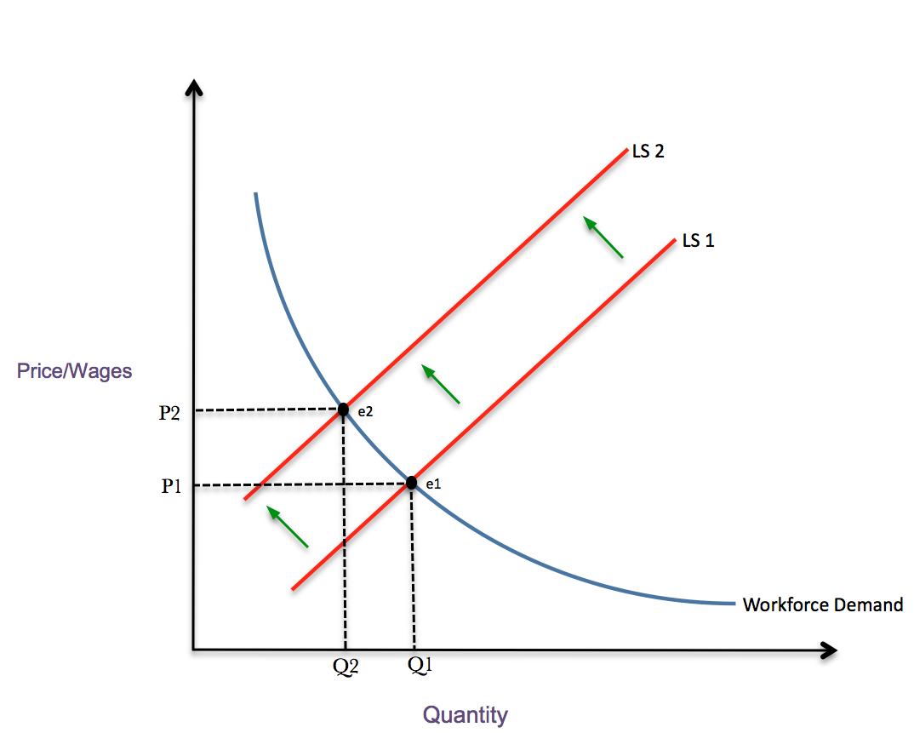
Figure 2 – Labour supply and demand (illustration)

One way it could tackle this problem would be to try and bridge the huge gap of inequality between its rural and urban areas. Providing children in rural areas, with the same levels of education, as those in urban areas would mean China can have a larger skilled workforce (than in preceding decades).

Government policies need to be implemented to provide equal access to education across the country. China can take advantage of its population, the largest in the world at 1.34 billion people (BBC, 2009), and look at it as a potential labour pool. China must try and reduce the effects of the ageing population by making sure it has a young skilled labour force.

China also needs to tackle the widespread corruption especially within the higher ranks in government. Corruption poses a great threat to the economy as it means resources are being drained away from investments and undermines the government. A report from Carnegie Endowment in 2007 estimated that corruption could be costing as much as $86 billion annually in China and BBC figures show that corruption among senior government officials increased by 2.9% in 2009. This level of corruption hinders the progress of the economy greatly as it threatens the reputation of China when doing business globally or when countries contemplate investing in China.

“Corruption has not yet derailed China’s economic rise, sparked a social revolution, or deterred Western investors… it would be foolish to conclude that the Chinese system has an infinite capacity to absorb the mounting costs of corruption. Eventually, growth will falter”.

Mixin Pei (2007)
References

Books:

Naughton, B., (2007). The Chinese Economy: Transitions and Growth. Cambridge: MIT Press Books.

Sieren, F., (2007). The China Code: What’s left for us?. New York: Palgrave MacMillan.

Yeoh, E.K.-K. and Devadason, E., (2007). Emerging Trading Nation in an Integrating World: Global Impacts and Domestic Challenges of China’s Economic Reform. Kuala Lumpur: Institute of China Studies University of Malaysia.

Web:

Hays, J. (2010). Technology Industries in China [online] Facts and Details. Available from: http://factsanddetails.com/china.php?itemid=357&catid=9&subcatid=61 [Accessed 7 November 2010]

The Economist, (2010a). Talking about reform in China.Change you can believe in? The prime minister calls frankly for political reform [online] Beijing: The Economist Newspaper Limited. Available from: http://www.economist.com/research/articlesBySubject/displaystory.cfm?subjectid=478048&story_id=16891829 [Accessed 7 November 2010]
The Economist, (2010b). China’s struggling smaller firms. Small fish in a big pond. They do more for China’s economy than big firms—but get less help [online] Beijing: The Economist Newspaper Limited. Available from: http://www.economist.com/research/articlesBySubject/displaystory.cfm?subjectid=478048&story_id=E1_TQQDJVRQ [Accessed 7 November 2010]

Trading Economics, (2010). China GDP Growth Rate [online] Available from: http://www.tradingeconomics.com/Economics/GDP-Growth.aspx?symbol=CNY [Accessed 7 November 2010]

Understanding the WTO by World Trade Organization
Information and External Relations Division © WTO 2010 <http://www.wto.org/english/thewto_e/whatis_e/tif_e/utw_chap1_e.pdf> [accessed 05.11.10]
The Impact of Joining WTO on China’s economic, legal and political institutions by Gregory C. Chow, Princeton University, <http://www.princeton.edu/~gchow/WTO.pdf> [accessed 23.10.10]
<http://www.starmass.com/china_review/imports_exports/china_top_trade_partners.htm> [accessed 06.11.10]
<http://www.journal-neo.com/?q=node/486> [accessed 08.11.10]

http://www.fco.gov.uk/en/travel-and-living-abroad/travel-advice-by-country/country-profile/asia-oceania/china?profile=economy

http://news.bbc.co.uk/1/hi/world/africa/country_profiles/1287798.stm

http://www.economywatch.com/world_economy/china/
http://online.wsj.com/article/SB126310314103423521.html

http://www.businessweek.com/news/2010-05-14/china-to-boost-private-investment-to-sustain-growth-update1-.html

http://www.straitstimes.com/Overcoming%2BThe%2BStorm/Latest%2BStories/Story/STIStory_425103.html

http://www.todayonline.com/Commentary/EDC101103-0000042/Chinas-war-on-inequality

http://www.carnegieendowment.org/publications/index.cfm?fa=view&id=19628

Bibliography

http://www.thefreelibrary.com/China's+aging+problem:+limited+options,+ominous+risk-a0154866721

