**Numerical solutions of equations**

***Solving x6 -5x2-4 =y using Change of sign method:***

In order for me to solve ***x6 -5x2-4 =y*** I will use the decimal search variant of the change of sign method. The graph below shows the above equation. I have drawn the graph using autograph.

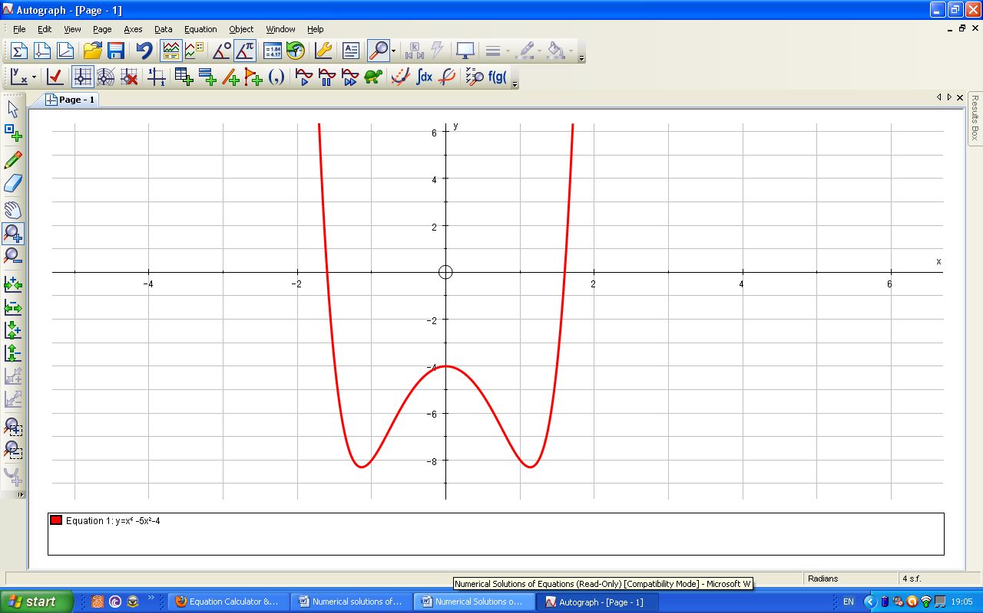

As you can see in the above screenshot my equation of ***x6 -5x2-4 =y*** has two roots. I will use the method to solve the positive root. From looking at the graph it is obvious to me that root of the equation is in between **X=1** and **X=2.**

To use the change of sign method to solve the equation for the one positive root I will input the formula of ***x6 -5x2-4 =y*** into excel. I will then have to input values of x between one and two in order to work out the function of x. wherever a change of sign, i.e. from negative to positive or vice versa, should occur a root is said to occur. I will do this method to 5 decimal places which means the method must be used four times and then rounded to **0.00005** i.e. five decimal places.

The screenshot below shows the formula of ***x6 -5x2-4 =f(x)*** with 1 substituted as X in order for the formula to be dragged down to the other values of x where the root could lie.

|  |  |
| --- | --- |
|  |  |
| From the screenshot below it is obvious that root is somewhere between 1.6 and 1.7 as the values f(x) have changed from negative to positive at this point. Hence I must repeat above formula for values between 1.6 and 1.7. |  |
|  |  |
| The screenshot below shows that the root must lie between 1.6 and and 1.61 as there has been another change of sign from negative to positive. |  |
| The screenshot below shows that the root is in between 1.6 and 1.601 as another change of sign has occurred. |  |
|  |  |
|  |  |
|  |  |
|  |  |
| The screenshot on the left shows that the root lies in between 1.6004 and 1.6005 due to the change of sign. As an accuracy of only five decimal places is required I will take the root as being in between 1.6004 and 1.6005. Thus the root is **1.60045**  **+ or - 0.00005.**  The screenshot below shows me using the decimal search graphically to solve what the value of x is. It is a bisection method iteration that works in the same way as decimal search to find value. However it has given me the right point but to fewer decimal places. |  |
|  |  |
| There are occasions however, when the change of sign method will not work. For example the graph below of **y=x³–4x^4–3x–1.125** is touching the x-axis in between 0 and 1 so there would be no change of sign.  The table below is the result of the decimal search. As I had expected no change of sign has occurred because the root is touching the negative side of the x axis so all the points must be negative values of x unless of course the graph does go above the x axis. However the roots that would occur would only be a very small interval of x much smaller than the scale of not 0.1 in the table below. So this change of sign would not be apparent. |  |
|  |  |

***Solving x^4+3x²−1=y using the Newton Raphson Method***

In order for me to solve the equation of x⁴+3x²−1=y I will use the Newton-Raphson method. Below is the graph of x⁵+3x²−1=y. These are the two roots that need to be found.

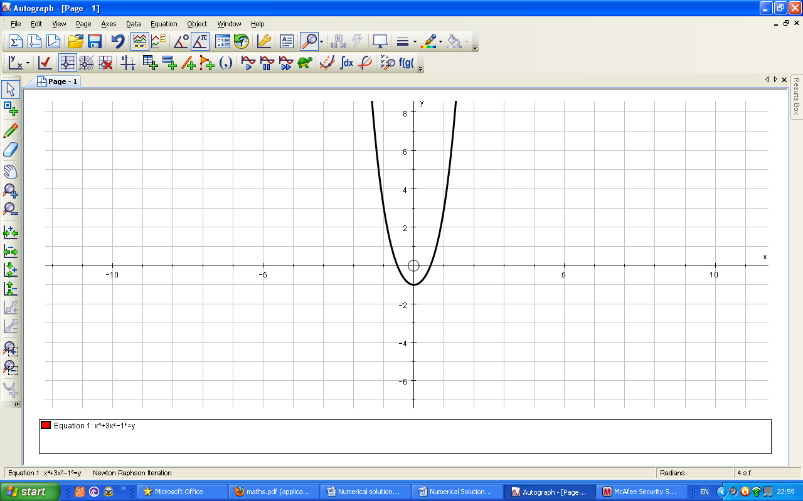

The iterative formula for the Newton-Raphson method is:

xn+1=xn- f(xn)

f’(xn)

For the equation of x⁴+3x²−1=f(x) my iterative formula will be

**xn+1 = xn- xn4+3xn2-1**  
 **4xn3+6xn**

I will find the negative root first using the formula and I will then proceed to find the positive root illustrating it graphically using autograph. In order to work the negative root I will use x0 =-2 as the starting point. The process below is me implementing the first value of -2 into the equation.

**xn+1 = 2- 24+3(2)2-1**  
 **4(2)3+6(2)**

**xn+1 = 2- 27**  
 **44**

**xn+1 = 2- 16+12-1**  
 **32+12**

**xn+1 = 1.38637 (to 5 decimal places)**

**xn+1 = 2- 0.6136363636 etc**

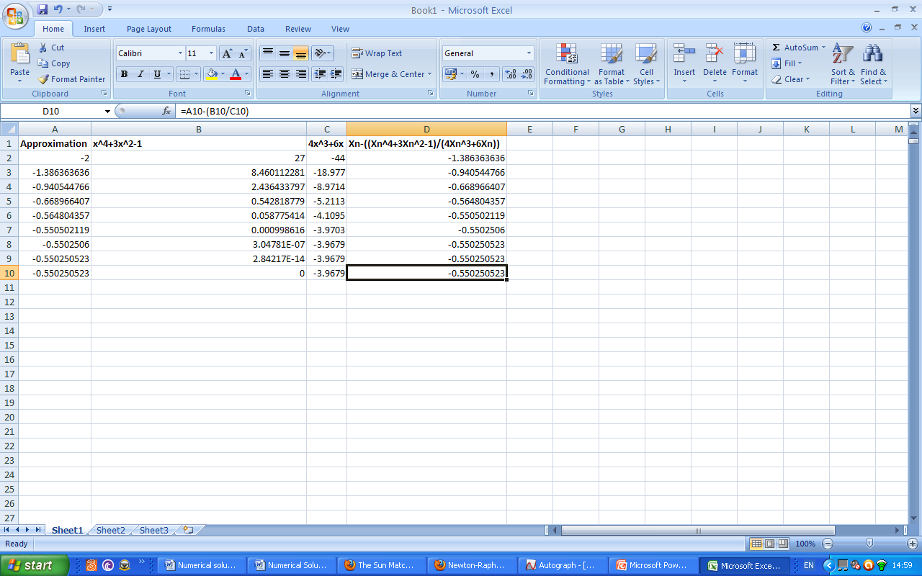

The screenshot above shows that the value of the negative root is -0.550250523 because the values of x have converged to this point of x7 and has stayed the same for the next value of x8 indicating that the point which the values of x were converging to, has been reached. The headings in bold in the above screenshot show the formula I used for that particular row by simply implanting my first value of x,-2, into it and then dragging this formula down for each row. Therefore the negative value of x in my graph of **x⁴+3x²−1=y** is **-0.550250523 to 9 decimal places**

**Error Bounds=+ or – 0.0000000005**

As the graph is symmetrical I would expect the root of the positive value to be **0.550250523**, if anything to a lesser amount of decimal places. I will illustrate this graphically on autograph.



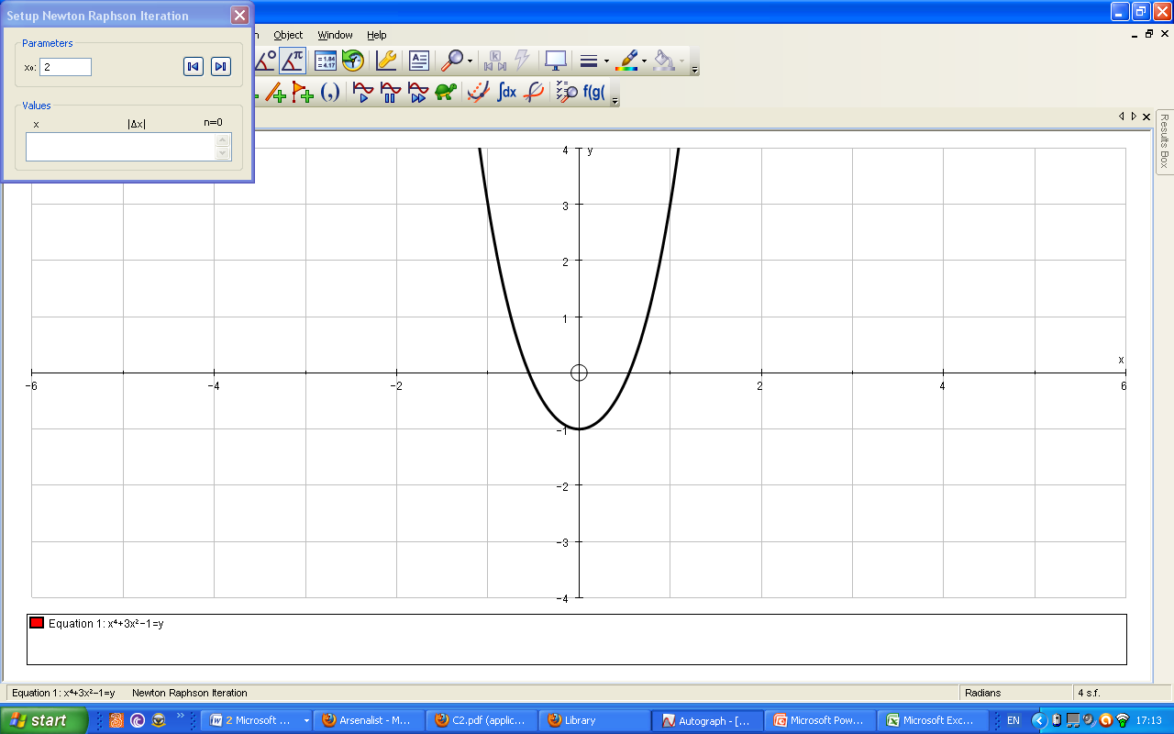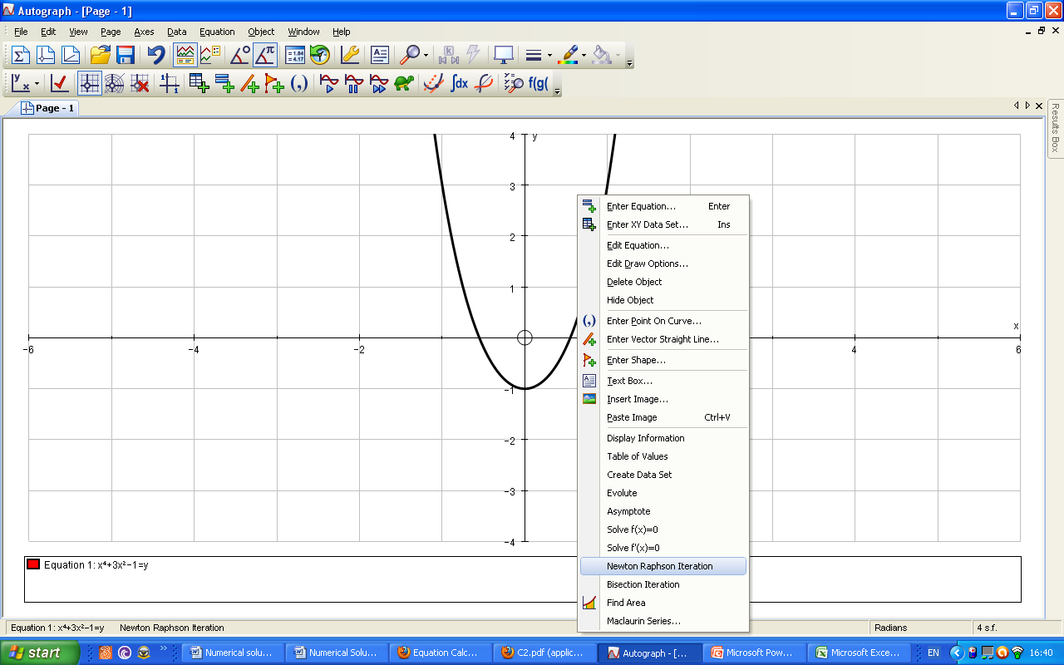The screenshot on the left shows me right clicking the graph and selecting the Newton raphson iteration on the drop down menu.  
The screenshot below shows the setup for the Newton raphson iteration. By looking at the graph I can tell 2 is the best starting point for the newton raphson iteration hence I have made the parameters 2.

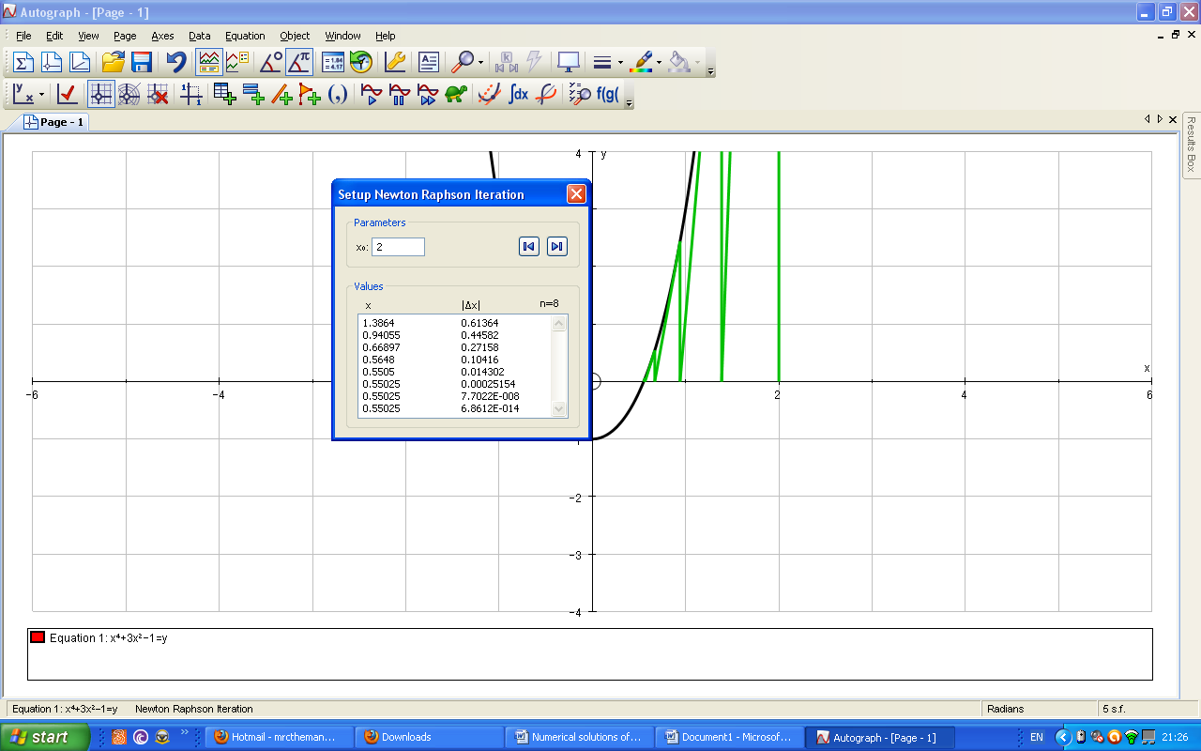I can safely say that the value of x is **0.55025** to 5 decimal places. The error bound for this value of x is **+ or -0.000005.** 6 Iterations has taken place to find the true value of the root with the 7th and 8th merely confirming that **0.55025** is the root.

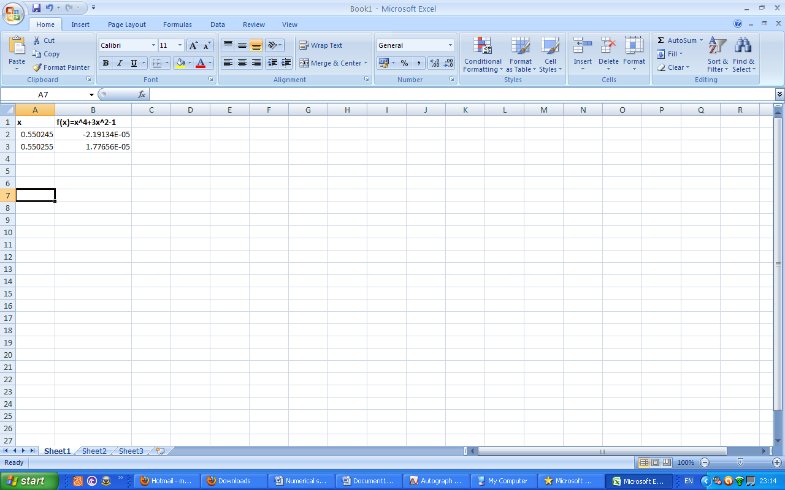

The screenshot on the left shows me applying the change of sign method to **0.55025 + or -0.000005.** This confirms 0.55025 is most likely the root as there has been a change of sign between 0.550245 and 0.550255 which implies the root is in between the two values i.e 0.55025.

I shall now illustrate an example when the Newton raphson method does not work.

Below is the graph of 2(x–1)²–1=y. The Newton raphson method can never work for such a graph as the nearest starting point to the root I wish to find, i.e. between x=1 and x=2, is above a stationary point. This is because the gradient of the second step that comes about from the starting point of 1 will be zero and so the process cannot proceed.

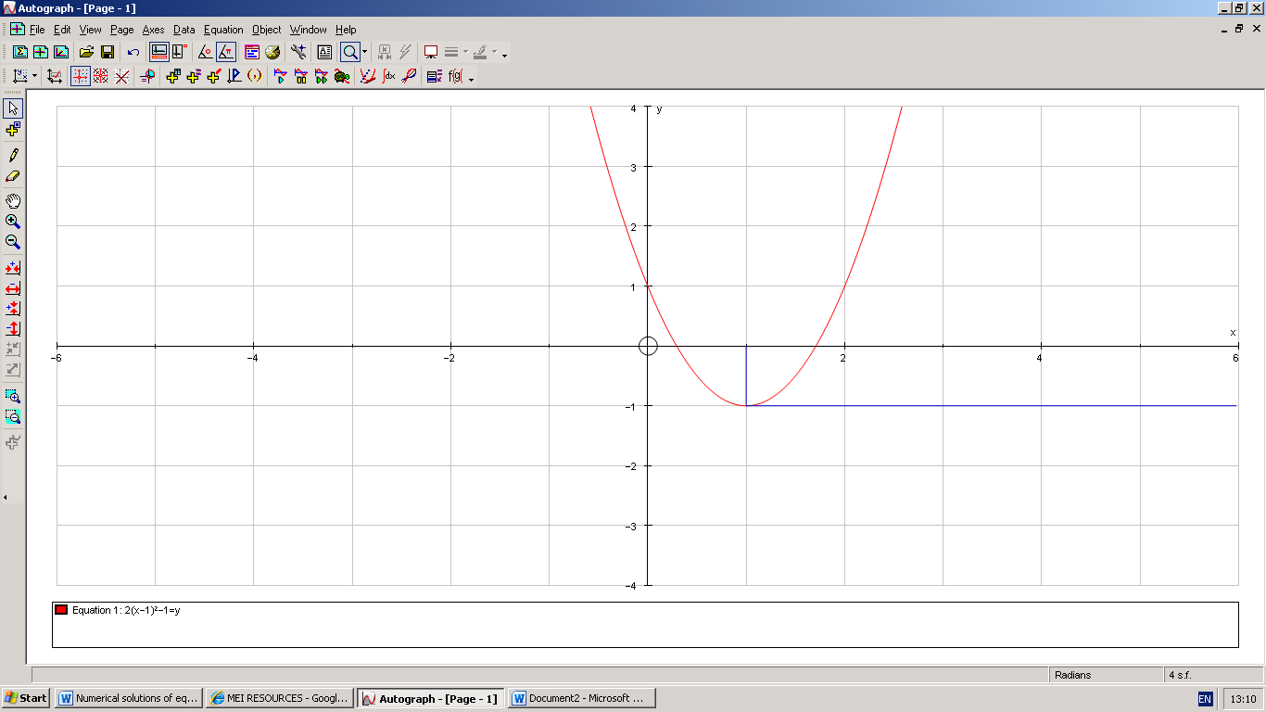

***Solving x5 -7x2+3 =y using rearrangement method***

The screenshot below shows the graph of **x5 -7x2+3 =y**. I will solve this root using the rearrangement method.

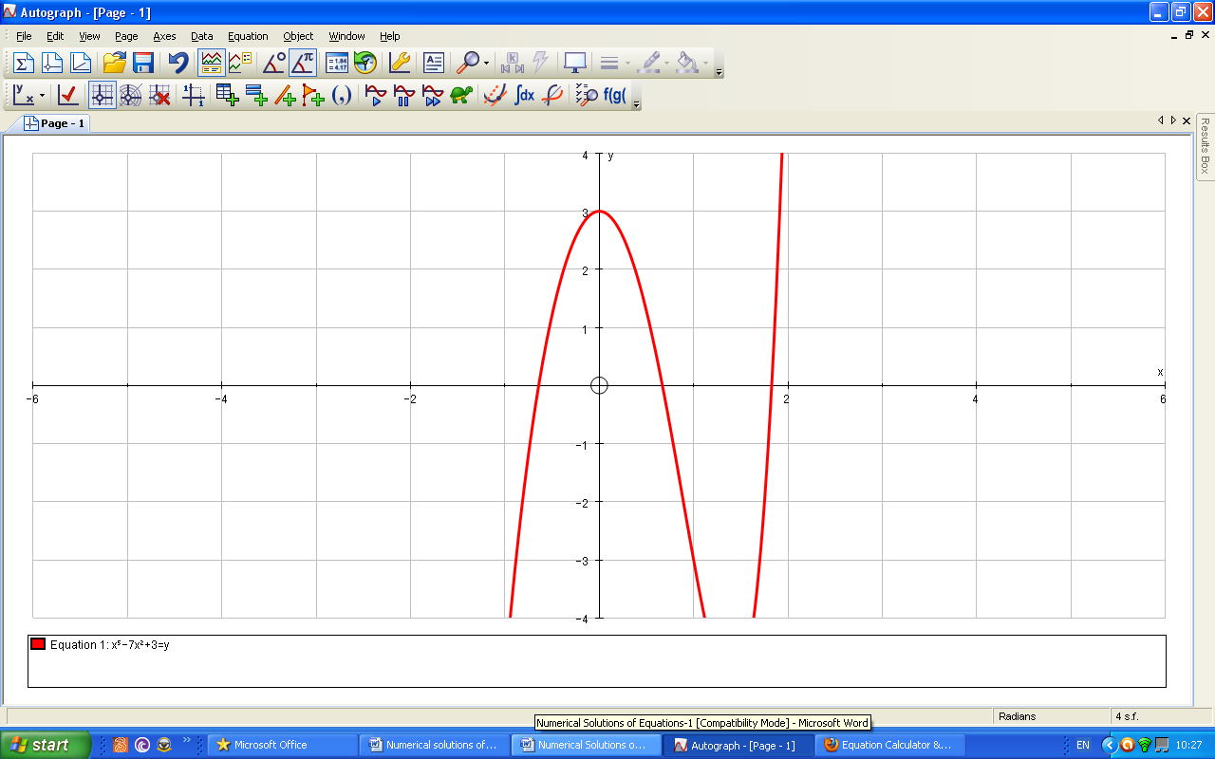

**xr+1 = g(xr)**

In order to carry out the rearrangement method I will simply make x the subject of my equation. I will then input this graph is autograph. I will also have to draw the graph of y=x. Where the two said graphs intersect will be the root of my equation. To find this root I will select both graphs and select x=gx on the drop down menu.

The iterative formula for this procedure in general is

The two rearrangements of x from the equation of **x5 -7x2+3 =0** in the above form are

**xr+1 =(xr5+3) 1/2**   
 **(7)**

**or**

**x = (x5+3) 1/2**   
 **(7)**

**xr+1 = (7xr2-3)1/5**

**x = (7x2-3)1/5**

I will use the iterative equation of



For simplicity.

The screenshot below shows the graphs of **y=x** *and*

**x = (x5+3) 1/2**   
 **(7)**

Intersecting.

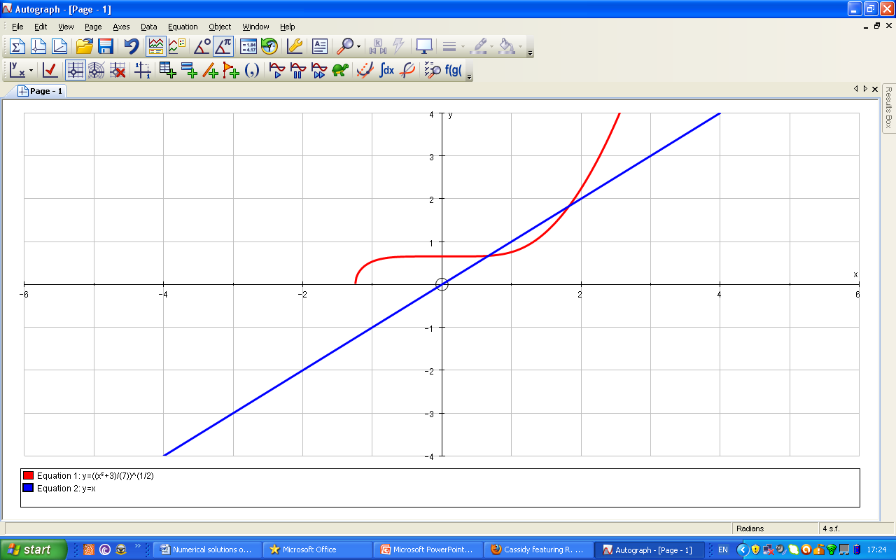

I can tell in the above diagram that my first point of x i.e. x0 must be 1. This is because 2 is past the intersection of the two graphs. The process below shows me inputting the agreed first value of x0(1) into the iterative equation. The next value of x(x1) is therefore 0.75593.

**xr+1 =(xr5+3) 1/2**   
 **(7)**

**xr+1 =(15+3) 1/2**   
 **(7)**

**xr+1 =(4) 1/2**   
 **(7)**

**xr+1 =0.75593 to 5 decimal places**

The screenshot below shows the rearrangement method iteration by graph. There have been 5 iterations to get the point of **0.66913 to five significant figures** which is the root as it has been repeated from the 6th iteration onwards.

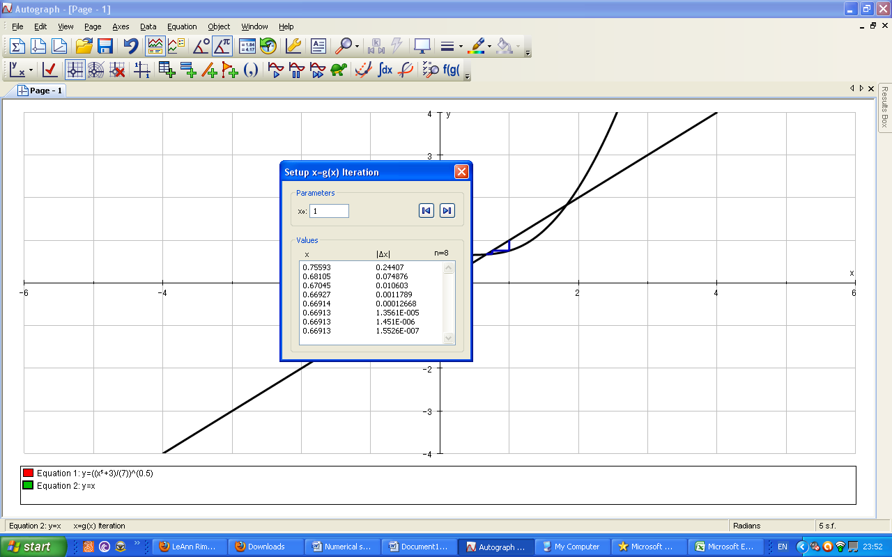



The root that I have found in the interval between X=[0, 1] appears to be solvable using the rearranging method. The reason for this being so is due to the gradient of the graph

**x = (x5+3) 1/2**   
 **(7)**

at the point of intersection with the graph of y=x being less than 1. This method can only work when the gradient of the graph of the used rearrangement equation is less than one and greater than -1 at the point that it intersects the curve Y=x. The Y=x curve shows gradient 1 as a change in x is always equal to a change in y. I can see for part of a graph to have gradient of less than 1 it must be less steep than the graph of y=x. E.g. the third graph I have put in the screenshot below is less steep than the graph of y=x. The gradient of the line is change in y/change in x which is ½ so the gradient of this new graph is 0.5. I will show that the gradient function of

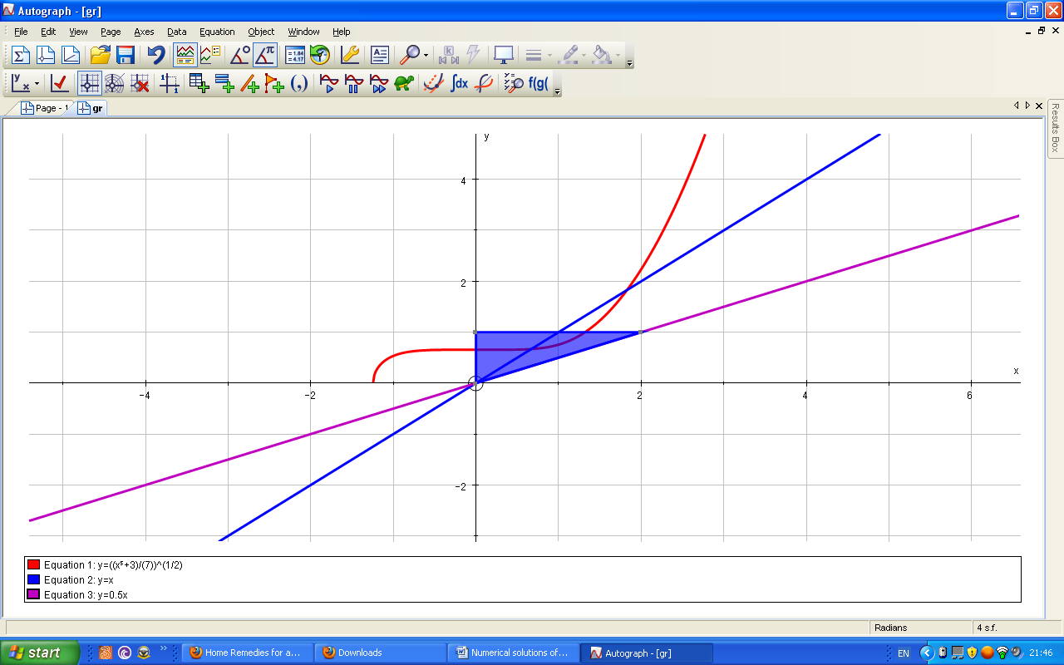

at the point of my root **0.6691** is less than 1.

**x = (x5+3) 1/2**   
 **(7)**

I can tell in the above screenshot that at the point of my root **0.6691** the graph of

**x = (x5+3) 1/2**   
 **(7)**

Is steeper than y=x and so the gradient is less than 1 at this point which is why the graph works.

**y =(x5+3) 1/2**   
 **(7)**

**y =1(x5+3) 1/2**   
 **√7**

**y =1 x 1(x5+3) 1/2**  
 **√7 2**

**X (5x4)**

**y =1 x 1 x 1**   
 **√7 2 √(x5+3)**

**X (5x4)**

**dy =(5x4)**  
**dx or g’(x) 2√7 x√(x5+3)**

The process being shown is the equation of the graph in question being differentiated. I will put my value of **0.66913 i.e. the root** into the differentiated equation and I should get answer less than 1 and greater than -1 as the rearrangement method appears to have been successful.

The process below shows me working out the gradient function at the point of my root. As I had predicted it is less than 1 but greater than -1 which is why I am able to find this root using the rearrangement method.

**dy =(5x4)**  
**dx or g’(x) 2√7 x√(x5+3)**

**dy =(5(0.66913)4)**  
**dx or g’(x) 2√7 x√((0.66913)5+3)**

**dy =1.00215**  
**dx or g’(x) 9.35893**

**dy**   
**dx or g’(x) at point 0.6691=0.10708**

I will now attempt to use the graph of the other rearrangement

**x = (7x2-3)1/5**

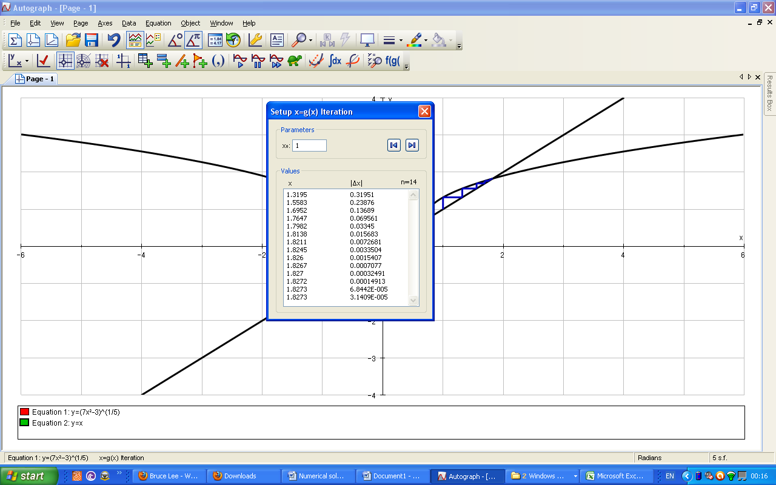To find the value of x in the interval x=[0,1]. In the graph below I have attempted to find a root to the left of my starting value for x which is one. However due to the fact the gradient, g’(x), is greater than 1 at this point (it is steeper than graph y=x) the rearrangement method fails and instead converges to any root it can solve i.e wherever the gradient is less than 1 and greater than -1 so at this point.

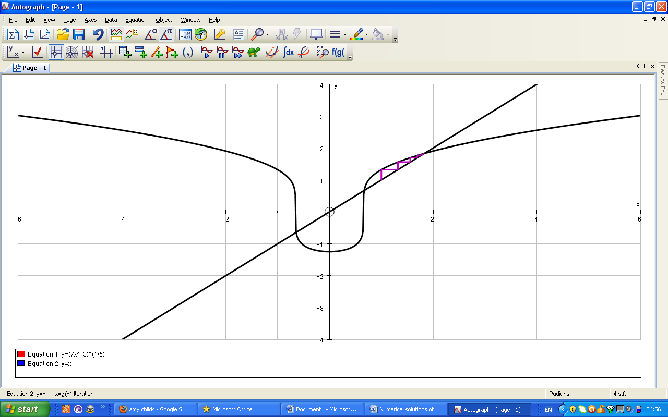

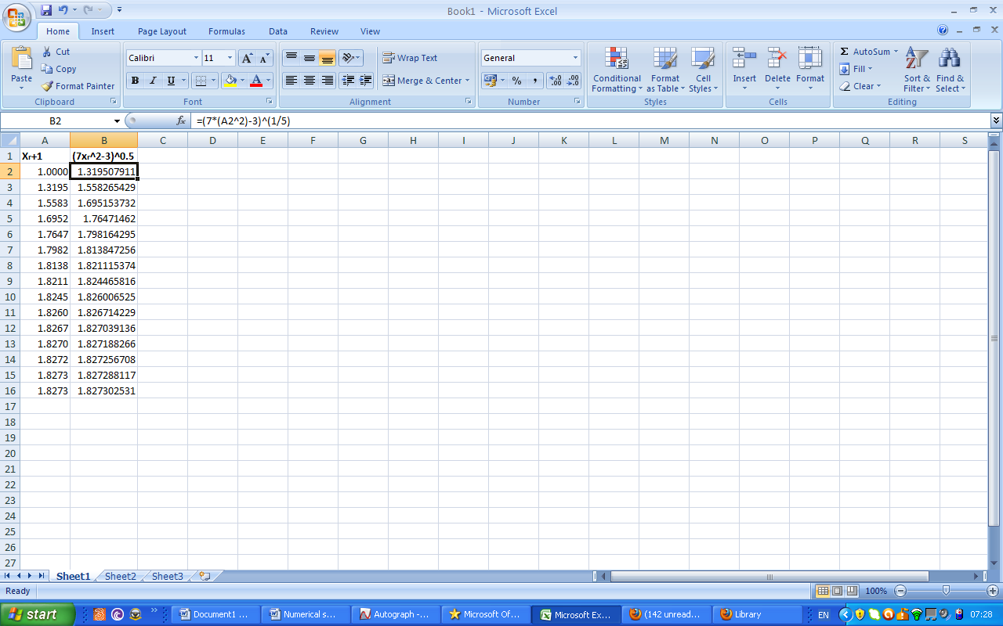I have again attempted to solve the root, this time using excel, and again the rearrangement method has converged to another root.

DY/DX or g’(x) below is just g(x) differentiated. I will put the root **(0.66913)** that I found from the other rearrangement into the equation. If this answer is less than -1 or greater than 1 it would explain why the root cannot be found using this rearrangement. As g’x has to be -1<g’x<1 for the rearrangement method to work on an equation.

**Dy**

**DX or G’(x ) =(14x)x 1/5(7x2-3)-4/5**

**Dy**

**DX or G’(x ) =(14(0.66913)x 1/5(7(0.66913)2-3)-4/5**

**Dy**

**DX or G’(x ) =(9.3674)x 0.9993=9.3609**

As I had suspected the g’(x) for the value of the root **0.6691** is greater than 1 or less than -1 which is exactly why the rearrangement method cannot work to solve it.

**Comaparison of Methods**

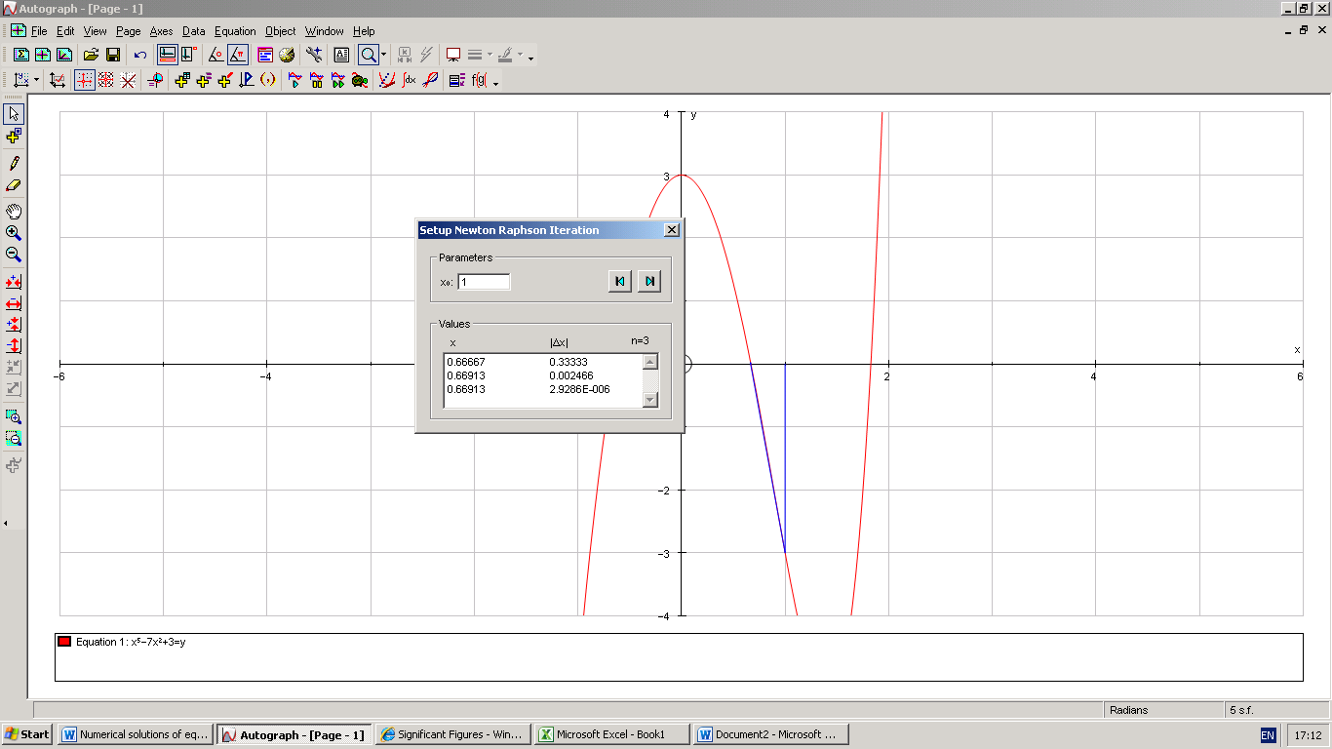 I will now use the equation of ***x5 -7x2+3 =y*** that I used for my rearrangement method for the other two methods i.e. Change of sign method and newton raphson method. As my starting value was 1 in the rearrangement method I must use 1 as the starting value for the other two methods. I should get an answer of **0.66915** to five significant figures. The screenshot below shows me using the newton raphson method to find the root of the graph ***x5 -7x2+3 =y.*** As seen in the diagram below there have been 3 iterations to get the required value of 0.6691 before it repeats and confirms itself as the root.

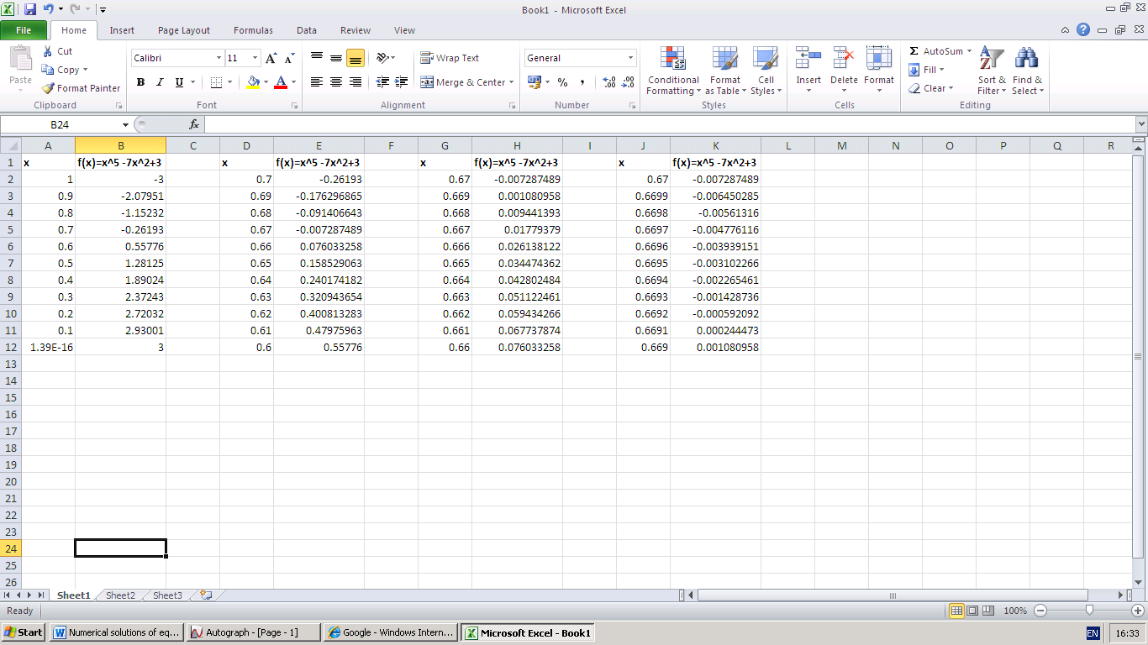I shall now use the decimal search in order to find the root **0.6691** of the graph ***x5 -7x2+3 =y.*** As I am required to use 1 as the starting value consistently in all the methods I will start from 1 with my decimal search. The screenshot on the left shows that there has been a change of sign between 0.7 and 0.6. Therefore the root lies somewhere between 0.7 and 0.6.

There screenshot below shows there has been a change of sign between 0.67 and 0.66 so the root is in between these values.



The screenshot below shows there has been a change of sign between 0.67 and 0.669 so the root is in between these values.

The screenshot below shows there has been a change of sign between 0.6692 and 0.6691 so the root is in between these values.

Thus the value of x is **0.66915 + or – 0.00005**. However I will take it to be **0.66915** to 5 significant figures.

**Evaluation of the methods**

As seen above with the examples of the Newton raphson method and the decimal search method the Newton raphson method took a shorter amount of time than the decimal search did. Whilst this was the case it does not mean to say that the decimal search is a complicated process. The benefit of the decimal search method is that it is the most straight forward method of the three in terms of time taken to fully understand and grasp the method. However the fact that all the tables have to be drawn on excel increases the timing of the process so much so that it can become lacklustre to use and increases the time taken to converge by the mere fact that it takes a relatively large amount of time to set up. Also all the different formulas that need to be inputted take up some time. Finally looking for the change of sign adds complexity to the whole process.

The same can also be of the rearrangement method. This is because there is a long process involved with setting up the graphs of the method because before the method can progress you have to spend time observing which graph works for the root of the equation you are trying to find and which graph fails. However once the required graphs have been set up it is a simple process using autograph to find the root as the values converge. All that is needed is to select the two graphs and choose x=g(x) iteration. However where the Newton raphson method takes 2 iterations to find the same root the rearrangement takes 8. So this implies to me that the rearrangement method can be used as the Newton Raphson’s substitute but Newton Raphson should always be used as the main method. This is because in terms of converging towards and finding the root the Newton raphson method takes a mere three steps. The graph takes minimal time to draw and there is no time spent trying to find out which graph needs to be used, as in the rearrangement method, as you can input the graph of your equation straight into excel.

In terms of the hardware used for the change of sign method it made the whole change of sign method easier exponentially. The computer sped up the whole process for the change of sign method because of its capability to harbour such programs like excel and even Microsoft word. Also there was access to the calculator program installed on the computer however for the change of sign it was not needed so much. Also compared to doing it by hand and calculator it made the whole process easier as to work to 5 decimal place would have been time consuming where excel does it instantly after having been formatted. In terms of the software that I mentioned above it was very easy to use excel. This is because excel has many different features such as fill dragging and enables you to input formulas for specific equations. With fill dragging I was easily able to copy formulas to all the other values of x that needed to be found.

Comparatively hardware also made the rearrangement method and Newton raphson simpler. The processing power that the computer has to power such necessary programs i.e. autograph was vital to the whole process. However in general the computer was no easier or harder to use with the change of sign, rearrangement or Newton raphson methods. The Calculator was more necessary to use for Newton raphson and rearrangement as iterations had to be shown by hand. I would say that it was easier t use the calculator on the rearrangement method as the iterative formula for the rearrange generally had more simplicity. Therefore there was less scope for error when inputting the calculations into the calculator. In terms of using excel it was probably easiest to use the Newton raphson method on it. This is because as mentioned beforehand Newton raphson has the shortest iterations of the three methods. Added to the fact that it was being done on excel with its ability to calculate functions and equations it took the least time out of the three hence it was the easiest method using excel out of the three. I also think Newton raphson was easiest method to use on autograph due to its shorter iterations and due to the fact that you didn’t have to work out which graphs needed to be used as in the rearrangement method. In conclusion I believe Newton raphson was the best method to use.